**Java Interview Points**

Variables that are defined inside the class and if they are non-static then those variables are called as instance variables. Instance variables use heap m/m

Variables that are defined inside the class and if they are static then those variables are called as class variables.

Whenever we are creating attributes of a class for e.g  
Implement a `Student` Class: - Define a `Student` class with the following attributes: - `String name` - `int age` - `String studentId` - `List<String> courses`

The attributes are always instance variables. Instance variables should be private always because it needs to be protected from illegal value assignment.

String and List are non-primitive data types, so there default value will be null

e.g. String name;// here name is a reference variable as String is a non-primitive data type and the default value will be null

int, byte, short, double, float, char- primitive data types, so there respective values will be the default values

Constructors are used to initialise the instance variables

We don’t create objects of interface.

For e.g. List is an interface. List is implemented by Array List class. So if we want to initialise the instance variable private List<String> courses;

We need to create an object of the ArrayList and then initialise it inside the constructor.

Reference variable : unique identification hashcode of the object created in the heap m/m.

For e.g. Student s1; s1 🡪 reference variable

When an object is created , 3 things will happen

1. Class will be loaded in to the m/m
2. Instance variable will be created in the heap m/m
3. Constructor is getting called

We implement toString() method public String toString() to print the one line description of the state of the instance variable.

Public static void main(String[] args)

(String[] args) 🡪 Runtime arguments

Any method execution happens inside the stack, to add anything to stack we use push method

In the java execution flow at the top of the stack it will be ‘Main’ method

Variables inside the method are called local variables and it will be stored in stack m/m

Student s1. 🡪 s1 is a reference variable and Student is a non primitive datatype, so s1 is called as reference variable

In heap m/m instances variables will be created and it will be assigned to the default value for e.g string will have null , int will have 0, non primitive will have null as default values

Constructor is also a method and will be executed in the stack m/m

public Student(String name, int age, String studentId) {  
 super();  
 this.name = name;  
 this.age = age;  
 this.studentId = studentId;  
 courses = new ArrayList<String>();  
}

All the arguments of the constructors are local variables and its created in the stack m/m

When all the arguments are initialised to the corr variables the control will go inside the constructor

Super() keyword is always used to call the parent class constructor

Here parent of student is implicit parent will be the super class of all the classes which will be the object class constructor which is an empty constructor

This keyword 🡪 it is used to differentiate local variable with instance variable when they have the same name

Here local variables are name, age, id and courses and instance variables also have the same name

this.name 🡪 refers to the instance variables

So when we write ‘this.name=name’ then the instance variables in the heap m/m will be updated with the values of the local variables in the stack m/m

courses = new ArrayList<String>();

In this case the ‘courses’ is a reference variable which stores the hash code and here again an object of array list is getting created so when we create an object class will be loaded to the m/m, instance variable will be created and the constructor will be created. So again a reference variable will be created in the heap m/m of the arraylist and the default value of the course will store the hashcode

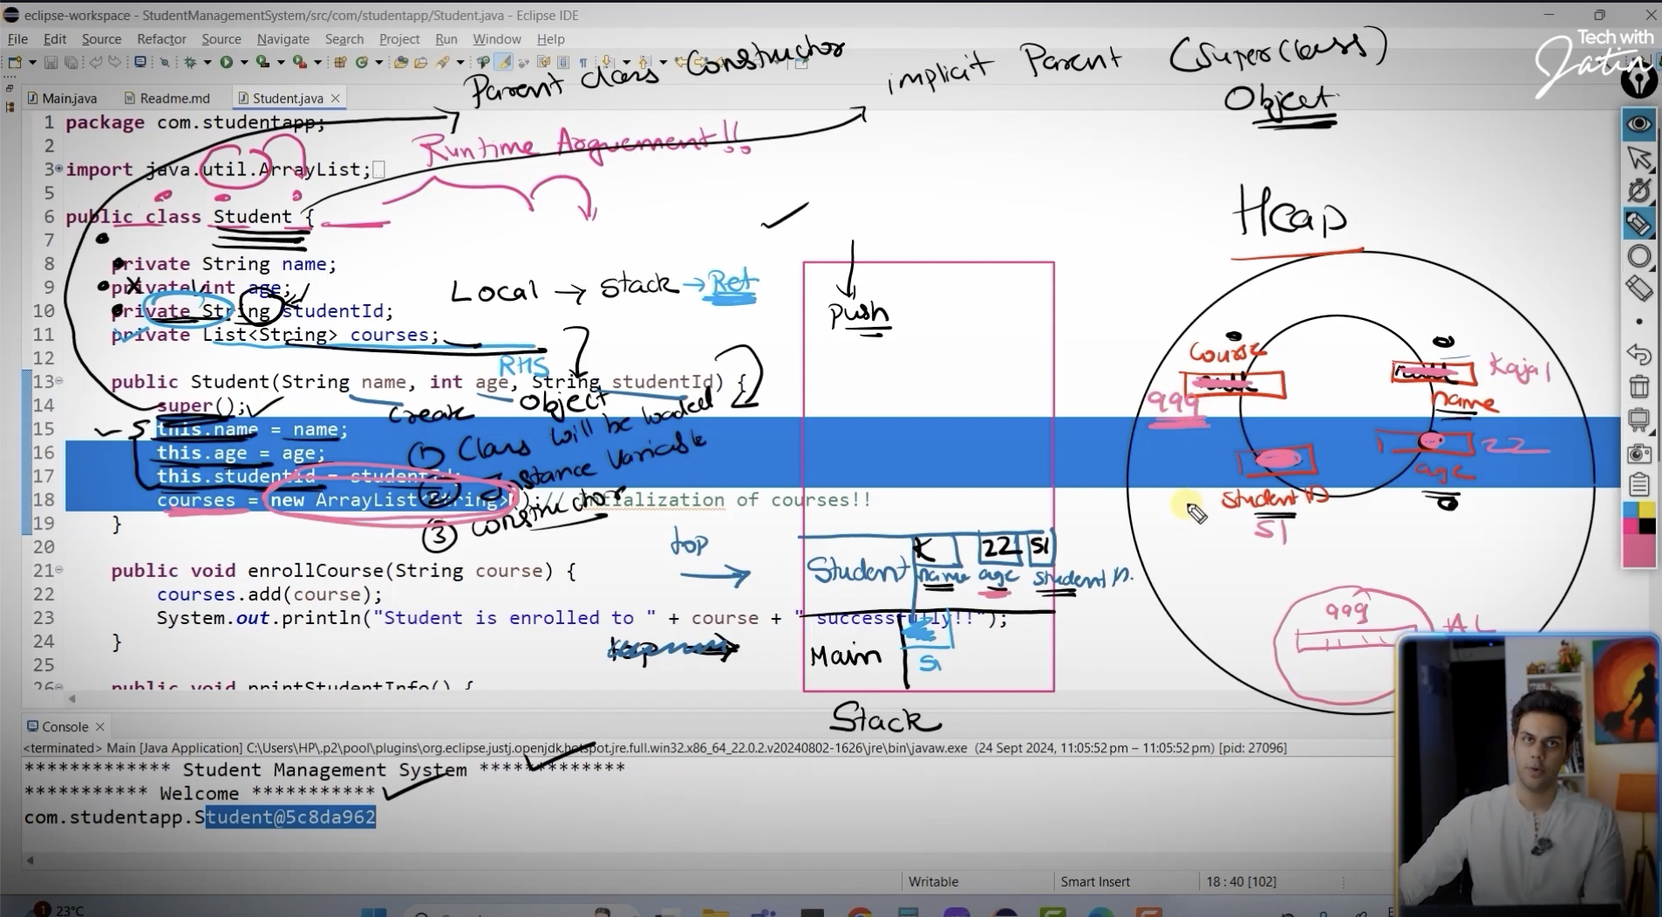

At the end of the constructor it will be popped out / removed from the stack and the control will again go the main method

So once the object is created in the heap m/m , it will have a unique identification and so s1 which is a reference variable in the stack m/m will be pointed to the object in the heap m/m and s1 , which stored some garbage value will now store the unique identification code of the object in heap m/m

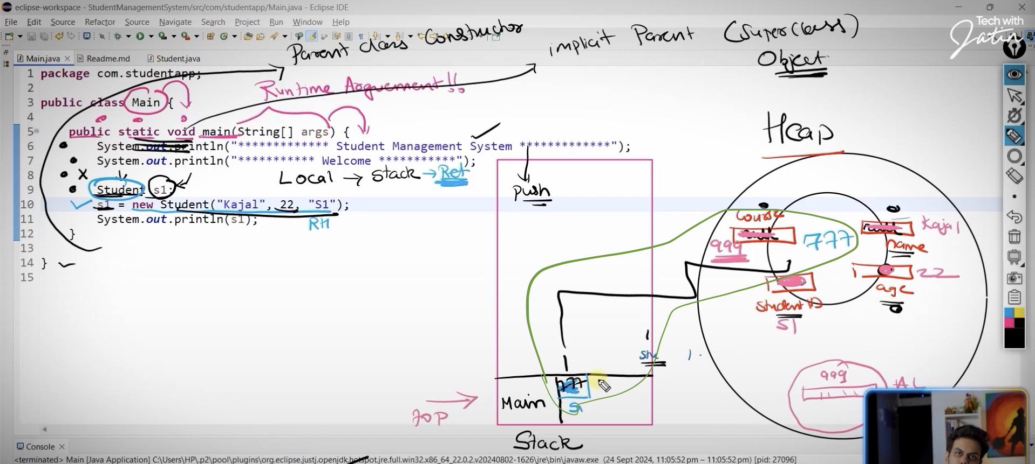

Regular expression

^[a-zA-Z] 🡪 it should start with an alphabet and it can either start with upper case or lower case ^ 🡪 start of the string

For e.g in accepts the following : kajal,Kajal,KAjaL

\\s 🡪 accepts the white spaces

+ 🡪 if we have different types of combinations, like combinations of first. Last and middle names

$ 🡪 end of the string

\\d 🡪 digits

**Pattern class**

It belongs to java.util,regex

It consists of a method called compile which is public static, compile method returns a pattern so we can create a reference variable to store the pattern, it’s a ref variable because ‘Pattern’ is a non-primitive datatype

Pattern namePattern=Pattern.*compile*(nameRegex);

Contains() method is used to check if a certain object is part of the arrayList

**ArrayList**

Non idempotent (contains duplicate elements). Therefore make sure when u call the add(), check if the element is already present in the list and then add it, if your scenario does not permit duplicate values

public void enrollCourse(String course){  
 if(!courses.contains(course)) {  
 courses.add(course);  
 System.*out*.println("Student is enrolled to the " + course + " successfully");  
 }else{  
 System.*err*.println("Student is already enrolled in the course "+ course);  
 }  
 }

contains() method is used to check if a certain object is part of the arrayList

List<Student> studentList=new ArrayList<Student>();

Each m/m location of the arraylist is a reference variable, which stores the unique identification in the heap m/m

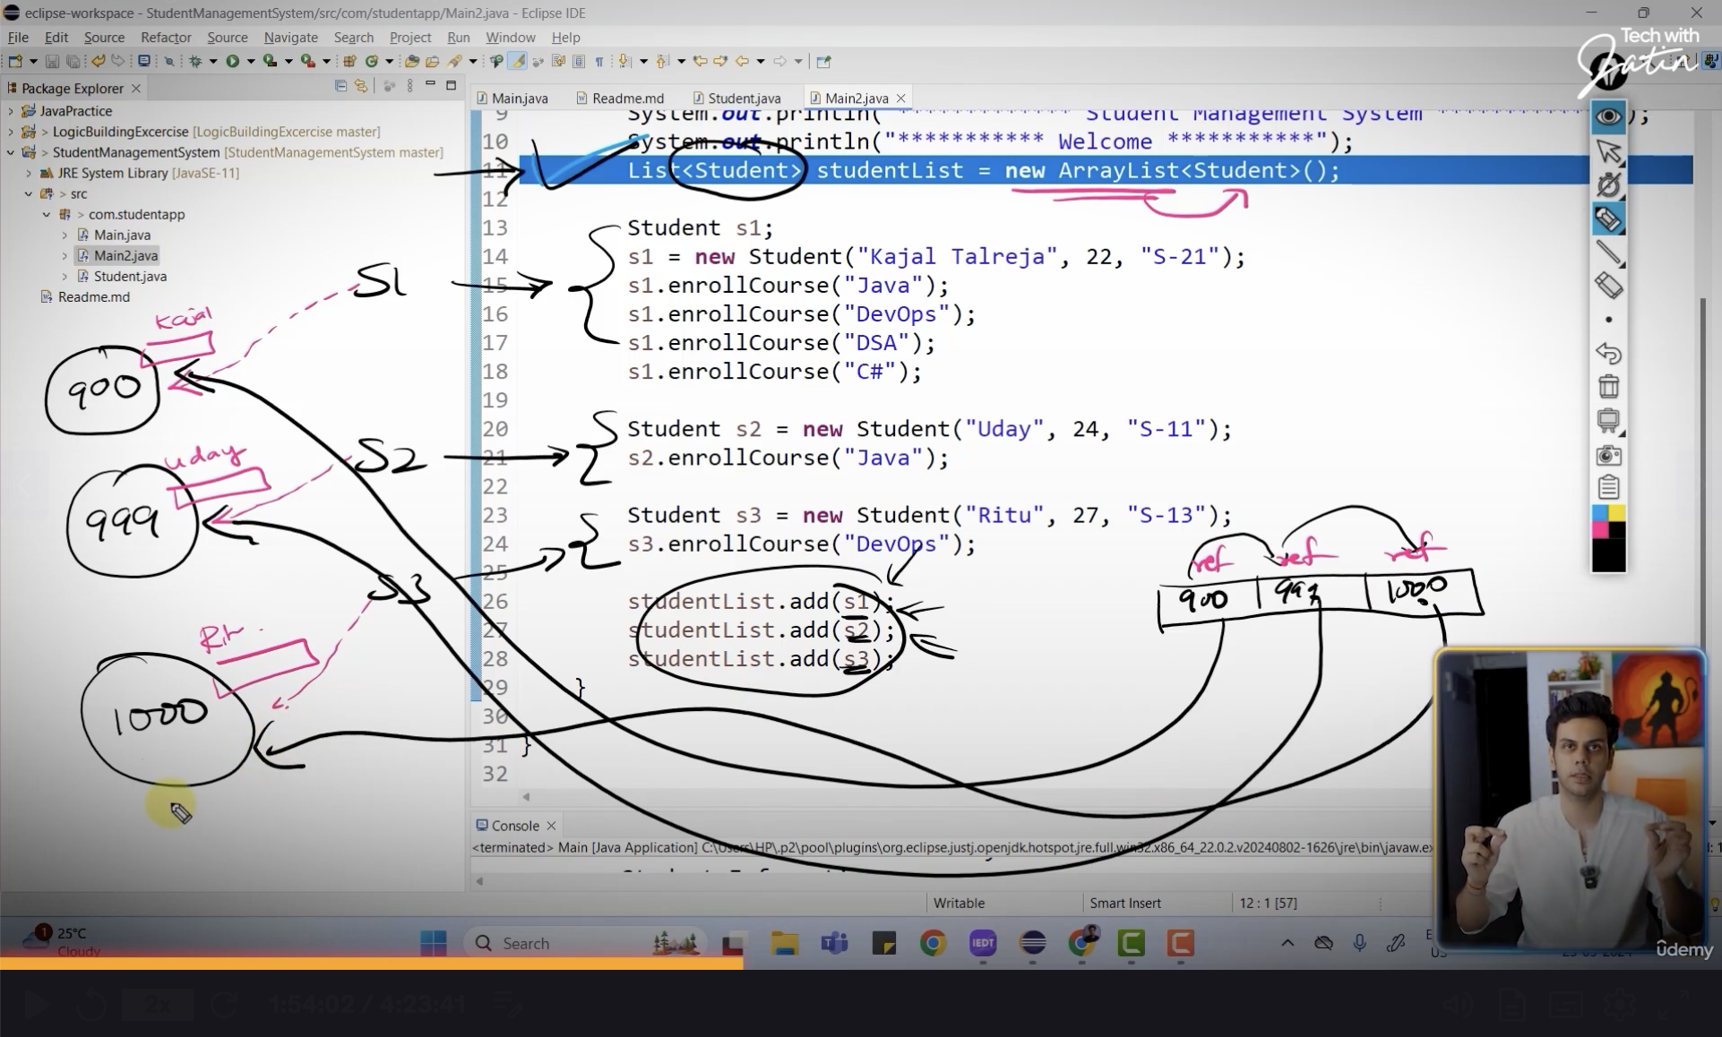

Write a method `Student findStudentById(String studentId)` that searches for a student in the list by their `studentId` and returns the `Student` object. If the student is not found, throw an appropriate exception with a custom message.

Static variables can be accessed in static method, if its non static then we need to create an object to access it

Local variables in a method cannot be accessible outside that method

Local variables are not initialised implicity, we need to initialise them explicitily. This is called explicit initialisation

Student result = null;

Student result=*studentList*.stream().filter(x ->x.getStudentId().equalsIgnoreCase(studentId)).findFirst()  
 .orElseThrow(()-> new RuntimeException("No data found !!!"));

This means whatever is stored in the *studentList* give one by one i.e stream it to the filter

List is given to the stream, then each one is filtered based on the student id and if its able to find anything it , it will be stored in the object reference ‘result’ else it will throw error

**Comparator – is an interface**

To sort something based on the instance variable, comparison mechanism for the collection

Comparator<Student> studentComparator=new Comparator<Student>() {  
 @Override  
 public int compare(Student o1, Student o2) {  
 return (o1.getName().compareTo(o2.getName())); *// compare the names lexographically(alphabetical order)* }  
};

Instance variables are always declared as private for encapsulation

**Encapsulation**

Bind the instance variables with public getters and setters. So that we can validate them.  
Before initialising itself ,inside a constructor, we can validate the instance variables, so that we can ensure the users are entering the correct values for the instance variables

Most imp variable in the appln should be instance variables

If we need to modify/update the instance variables we need to use the setters. If setters are not used, then it is immutable. So here as a we are not using any setters in the ‘Student’ class, it is immutable.

**Array and ArrayList**

**Array**

String[] courseArray=new String[5]

Here size of array is fixed, so it cannot be extended as it has fixed size and same datatype. It will throw ArrayIndexOutOfBound exception, if we exceed the array limit.

So java introduced Collections and it has an interface List

**List is implemented by ArrayList, ArrayList(class) is an extension of Array**List<String> courses = new ArrayList<String>();

String 🡪 is a non primitive data type

List<int> is not permitted as it is a primitive datatype. So in order to use it we should write List<Integer> where Integer is a class in java i.e. Wrapper classes

Wrapper classes are used for using primitive data types

Generics are used to avoid tpe checks and compile time errors

For e.g.

Int a[]= new int[5];

a[0]=10;

a[1]=12.5 // gives compile time error as the array will accept only integer values

List al=new ArrayList();

al.add(“Java”)

al.add(10)

al.add(12.5)

Here there is no type check so if we want to do some operations like  
al.get(0)/2; //This throws a compilation error because string “Java” cannot be divided by 2

Generics also helps in avoiding type casting. We can use only non primitive data types in generics. If we want to use int,float etc…we need to use there respective wrapper classes like Integer, Float for the primitive datatypes

Capacity of ArrayList= size*(50/100)

Capacity of StringBuffer and StringBuilder = 16 characters

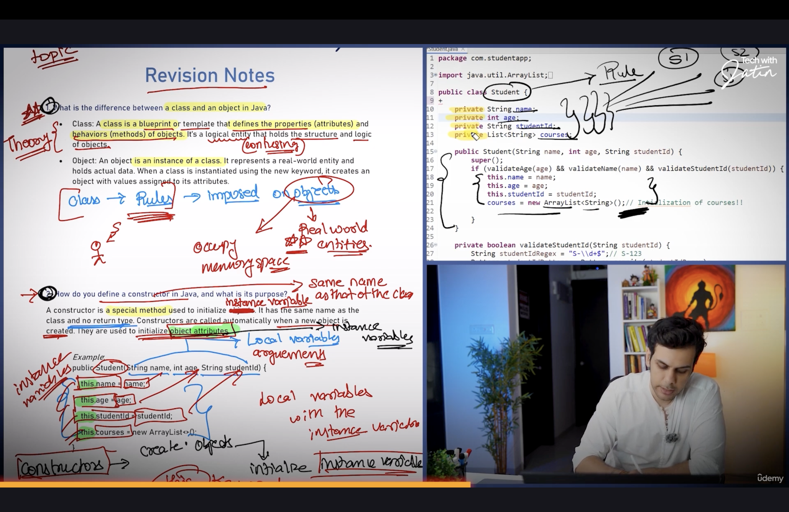

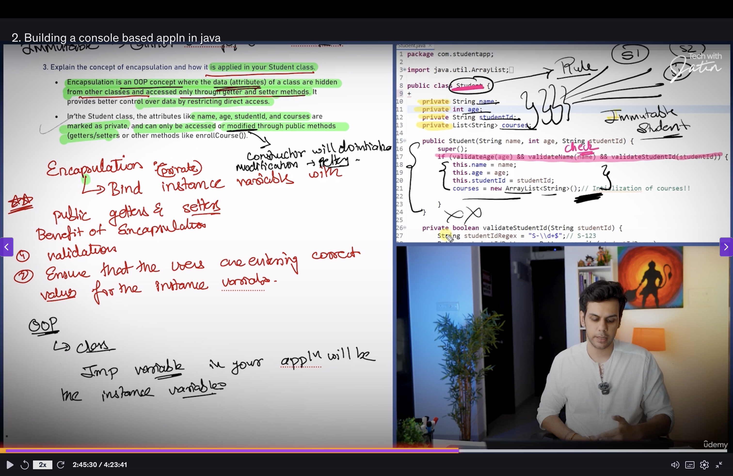

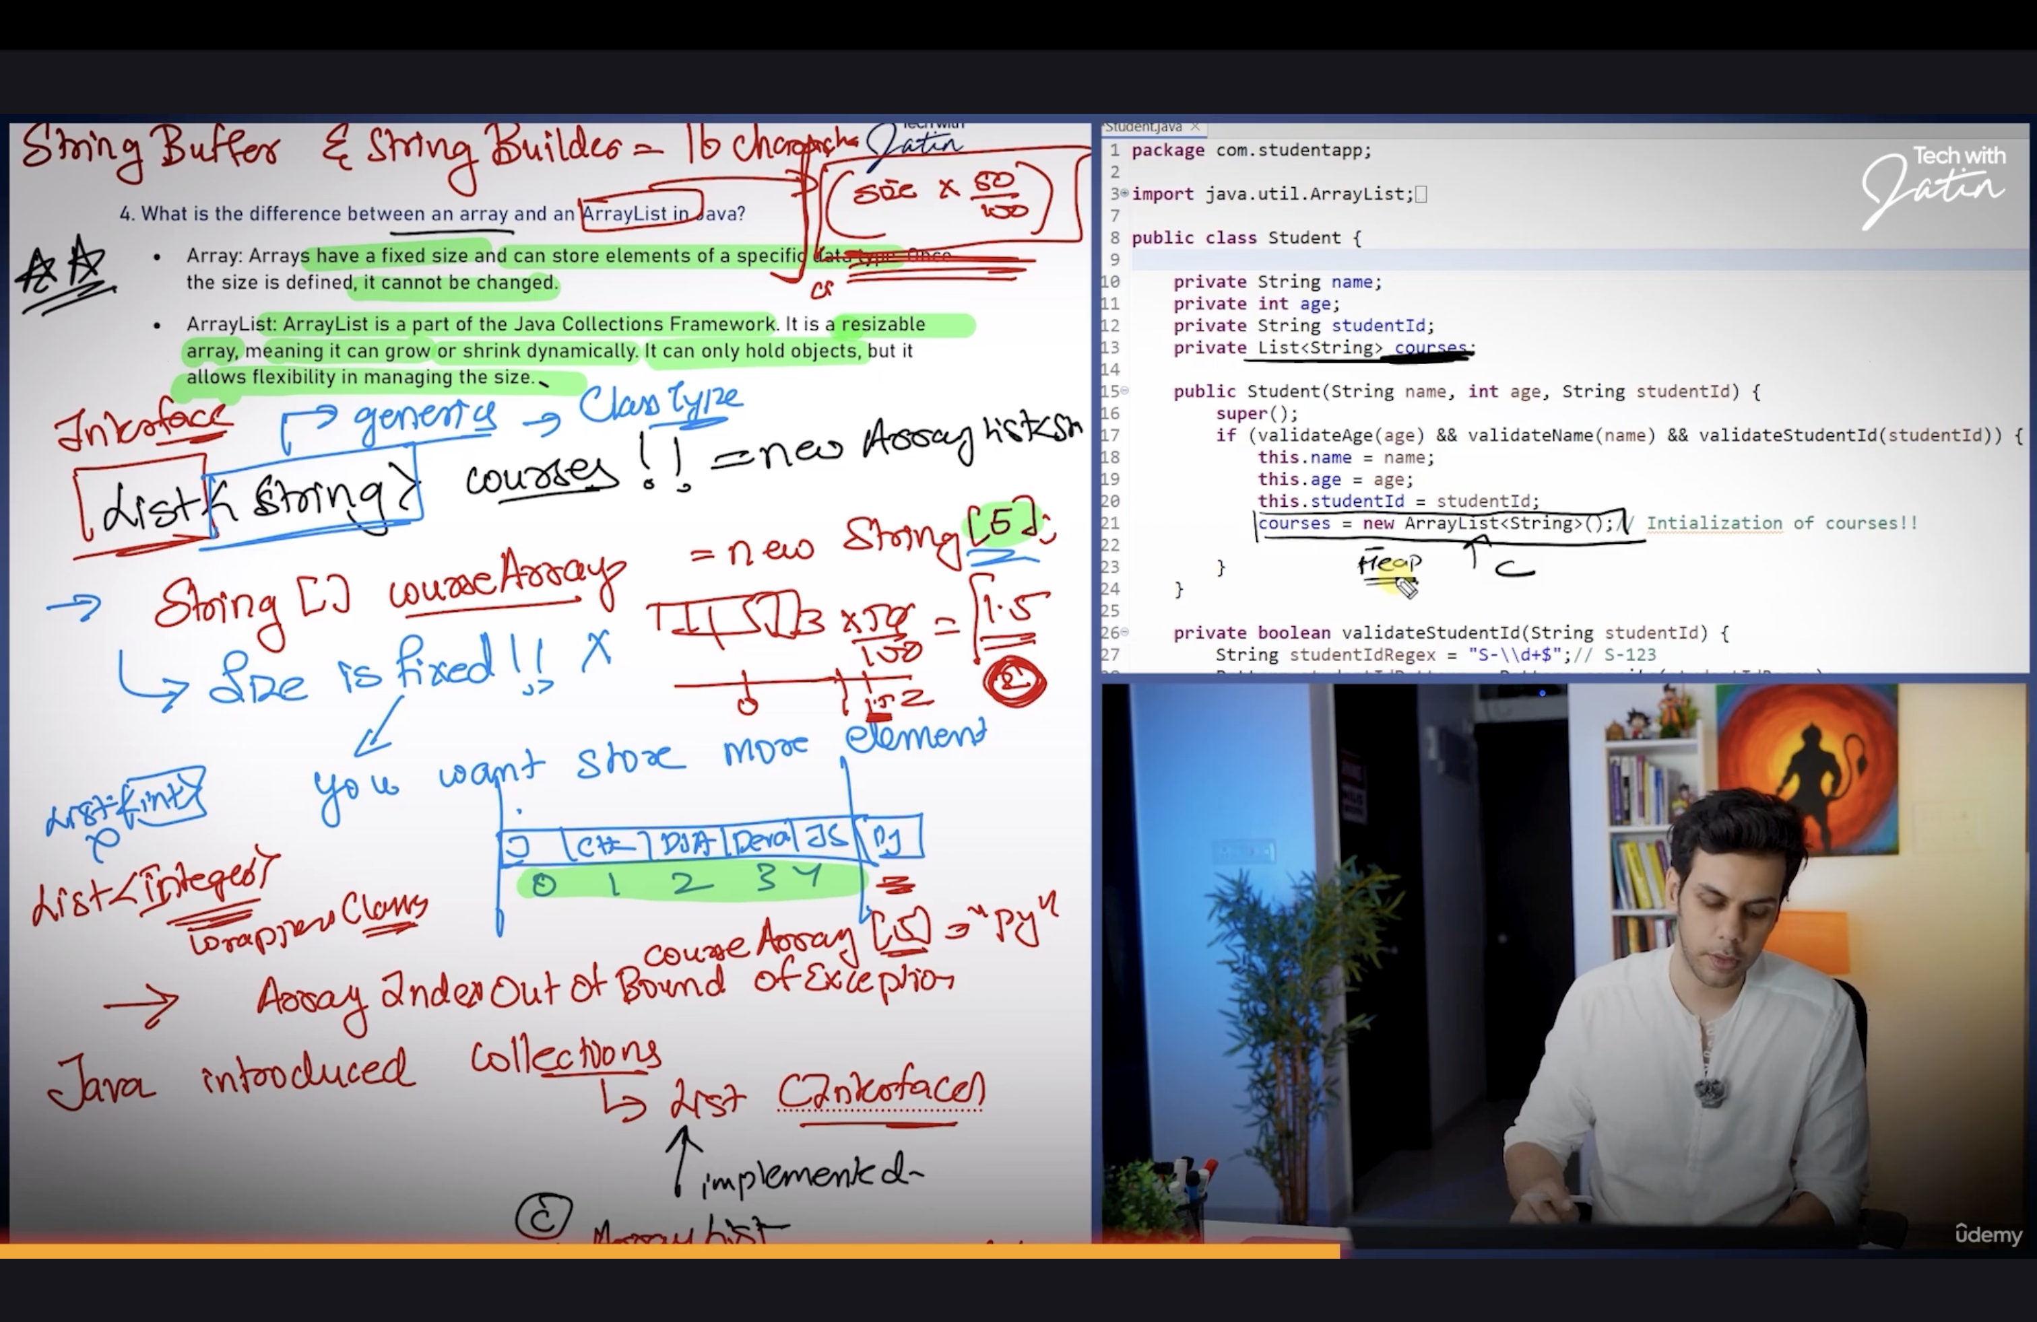

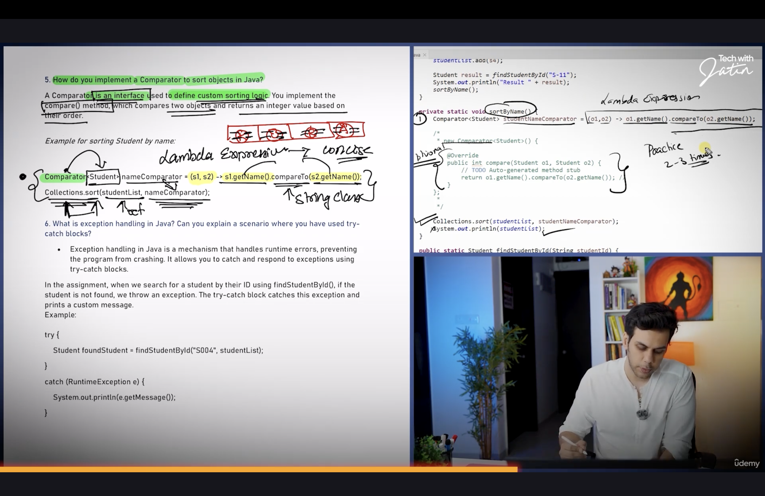

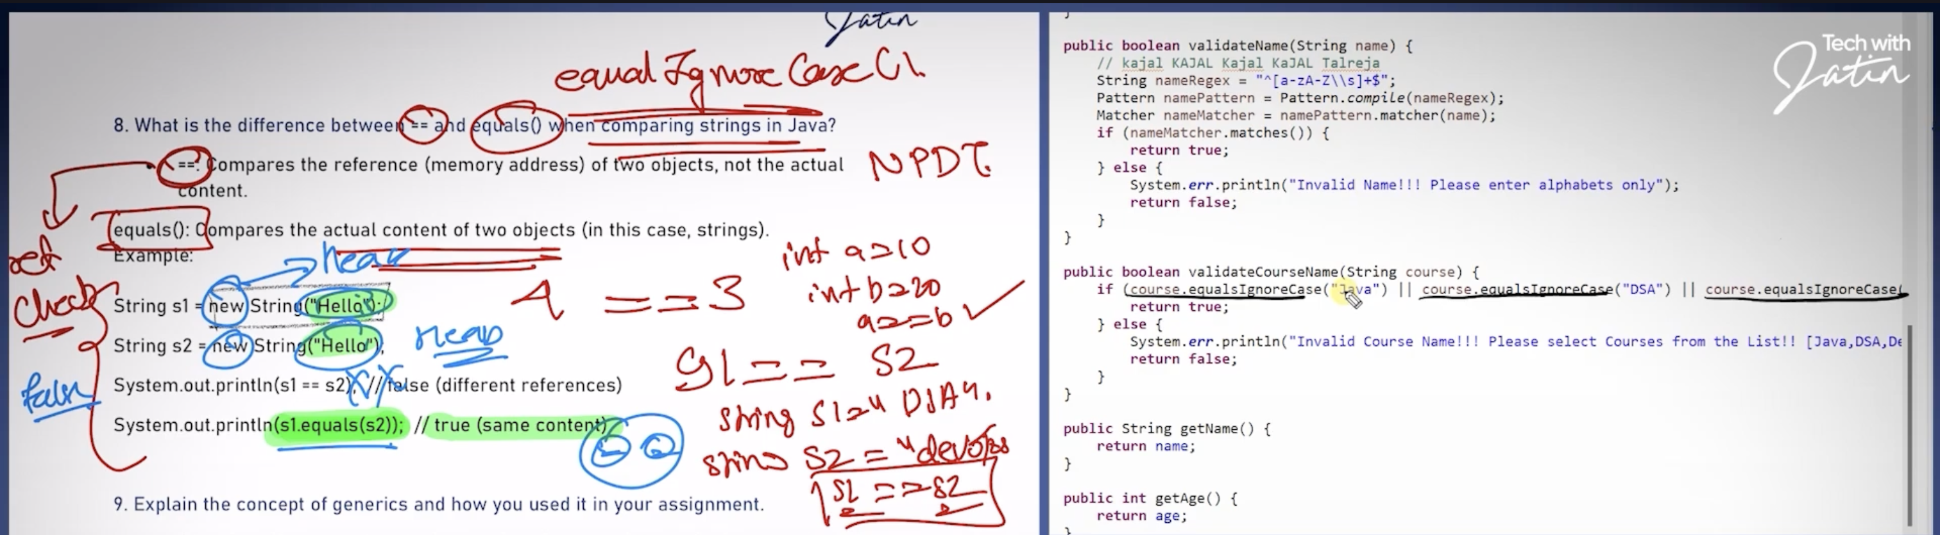

Try catch block is best way to handle exception as we can create custom messages for the exception

To throw an exception manually, use the throw keyword followed by an instance of the exception class.

Access modifiers

Default : public with in the package, and private for classes in different packages

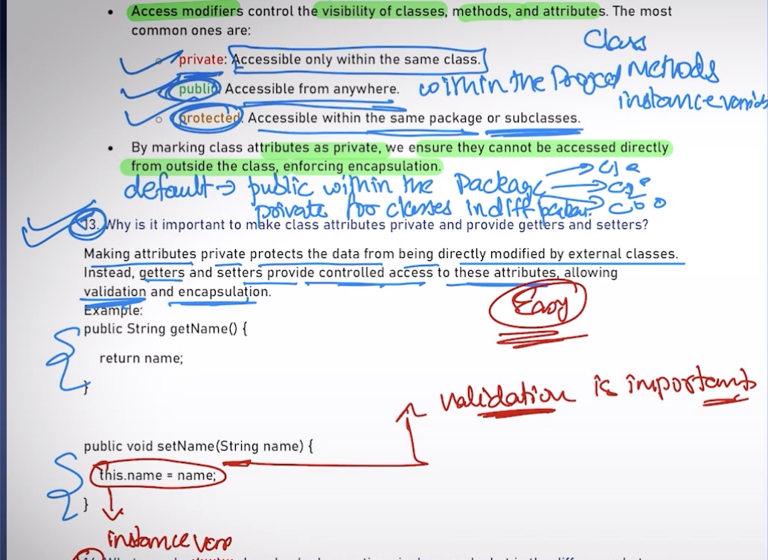

Example of null pointer exception

Student s1;

Sysout(s1.print()) // throws null pointer because the default value of s1 is null

Variables that are created inside the class and they are non static are called as instance variables and they are created in the heap m/m

Best practice in coding

1. Make sure that all the instance variables are protected from the invalid value assignment, for that create validation methods which is the error handling

For e.g. Here ‘age’ is an instance variable and it can’t be something like 122 so create ‘validateAge’ method

**Revision Notes**

**1. What is the difference between a class and an object in Java?**

* **Class**: A class is a blueprint or template that defines the properties (attributes) and behaviors (methods) of objects. It’s a logical entity that holds the structure and logic of objects.
* **Object**: An object is an instance of a class. It represents a real-world entity and holds actual data. When a class is instantiated using the new keyword, it creates an object with values assigned to its attributes.

**2. How do you define a constructor in Java, and what is its purpose?**

A **constructor** is a special method used to initialize objects. It has the same name as the class and no return type. Constructors are called automatically when a new object is created. They are used to initialize object attributes.

***Example***:  
public Student(String name, int age, String studentId) {

    this.name = name;

    this.age = age;

    this.studentId = studentId;

    this.courses = new ArrayList<>();

}

**3. Explain the concept of encapsulation and how it is applied in your Student class.**

* **Encapsulation** is an OOP concept where the data (attributes) of a class are hidden from other classes and accessed only through getter and setter methods. It provides better control over data by restricting direct access.
* In the Student class, the attributes like name, age, studentId, and courses are marked as **private**, and can only be accessed or modified through public methods (getters/setters or other methods like enrollCourse()).

**4. What is the difference between an array and an ArrayList in Java?**

* **Array**: Arrays have a fixed size and can store elements of a specific data type. Once the size is defined, it cannot be changed.
* **Array List**: Array List is a part of the Java Collections Framework. It is a resizable array, meaning it can grow or shrink dynamically. It can only hold objects, but it allows flexibility in managing the size.

**5. How do you implement a Comparator to sort objects in Java?**

A **Comparator** is an interface used to define custom sorting logic. You implement the compare() method, which compares two objects and returns an integer value based on their order.

***Example for sorting Student by name:***

Comparator<Student> nameComparator = (s1, s2) -> s1.getName().compareTo(s2.getName());

Collections.sort(studentList, nameComparator);

**6. What is exception handling in Java? Can you explain a scenario where you have used try-catch blocks?**

* **Exception handling** in Java is a mechanism that handles runtime errors, preventing the program from crashing. It allows you to catch and respond to exceptions using try-catch blocks.

In the assignment, when we search for a student by their ID using findStudentById(), if the student is not found, we throw an exception. The try-catch block catches this exception and prints a custom message.  
Example:  
  
try {

    Student foundStudent = findStudentById("S004", studentList);

}

catch (RuntimeException e) {

    System.out.println(e.getMessage());

}

**8. What is the difference between == and equals() when comparing strings in Java?**

* **==**: Compares the reference (memory address) of two objects, not the actual content.

**equals()**: Compares the actual content of two objects (in this case, strings).  
Example:  
  
String s1 = new String("Hello");

String s2 = new String("Hello");

System.out.println(s1 == s2);  // false (different references)

System.out.println(s1.equals(s2));  // true (same content)

**9. Explain the concept of generics and how you used it in your assignment.**

* **Generics** allow us to create classes, interfaces, and methods that can operate on any object type while providing compile-time type safety. It allows us to avoid type casting and provides flexibility.

In the assignment, we use List<Student> to store students***, ensuring type safety and avoiding runtime errors when accessing elements.***  
Example:  
  
List<Student> students = new ArrayList<>();  // This can only store Student objects.

**10. Can you explain how to throw and catch exceptions in Java? When would you use custom exceptions?**

* To **throw** an exception manually, use the throw keyword followed by an instance of the exception class.
* **Catching** an exception is done using a try-catch block where you handle the exception if it occurs.

***Custom exceptions*** *are useful when you want to define specific error conditions for your application. For example, you can create an exception when a student is not found by ID.  
Example of throwing an exception:***throw new Exception("Student with ID " + studentId + " not found.");**

**12. What are access modifiers, and how do they impact the design of your class?**

* **Access modifiers** control the visibility of classes, methods, and attributes. The most common ones are:
  + **private**: Accessible only within the same class.
  + **public**: Accessible from anywhere.
  + **protected**: Accessible within the same package or subclasses.
* By marking class attributes as **private**, we ensure they cannot be accessed directly from outside the class, enforcing encapsulation.

**13. Why is it important to make class attributes private and provide getters and setters?**

Making attributes **private** protects the data from being directly modified by external classes. Instead, **getters** and **setters** provide controlled access to these attributes, allowing validation and **encapsulation**.  
Example:  
public String getName() {

    return name;

}

public void setName(String name) {

    this.name = name;

}

**14. What are checked and unchecked exceptions in Java, and what is the difference between them?**

* **Checked exceptions**: These are exceptions that are checked at compile-time. The compiler forces you to handle them using try-catch or throws. Example: IOException.
* **Unchecked exceptions**: These occur at runtime and do not need to be explicitly handled in code. Example: NullPointerException, ArrayIndexOutOfBoundsException.  
  Difference:
  + **Checked exceptions** must be handled or declared in the method signature.
  + **Unchecked exceptions** do not need to be explicitly handled.

**Selenium Interview Points**

Test automation best practices

* 1. Clean coding
  2. Branching Model
  3. Design Pattern

Custom Reporting Mechanism in automation

1. Extent Report
2. Allure
3. Logging log4j

Optimise your test execution strategies

Components of Automation test framework

1. Reporting : Allure & Extent [config 🡪 where we control which report we want]
2. Logs : Log4j 🡪 All the appln logs and test logs needs to be generated
3. UI automation : Selenium WebDriver (latest version)
4. Test Library : TestNG – Executing tests from terminal or from testing.xml, in built reporting capabilities, retry logic(if the test fails, will return the failed tests) 🡪 IRetry Analyser, can achieve data driven testing using Data Providers
5. Data driven testing libraries:

For JSON : Jackson/gson

For CSV : opencsv

For excel :Apache POI

Fake test data creation : Fakor library

1. Code Quality : sonar check 🡪Sonar Lint Plugin, java coding statndards, code duplicates, length of classes and methods, code smells
2. Environment details in a property files
3. Utility components 🡪 Reusable method, webdriver methods will be wrapped in the custom class – BrowserUtility

Abstraction : hiding complex info, like we can create methods to read from json, csv and provide this wrapper method to the team members so that they needed not be aware of Selenium webdriver

1. Design Patterns : special ways of creating class that ensure that you are implementing OOPs in correct way  
   Page Object, Singleton, Factory Pattern
2. Feature using which I can execute my ATF via terminal, way of passing parameters like the diff browsers and also headless option
3. BrowserStack or Lamda Test to run the ATF in cloud

Creating ATF

/src/main/ java 🡪 development code i.e. .java files

/src/main/resources 🡪non java files like json, jpeg,png,css

Both these folders are for maintaining development related codes

For testing the following folders are used  
/src/test/java 🡪 test codes, test scripts

/src/test/resources 🡪non java files like json, jpeg,png,css,csv

Pom.xml 🡪 dependencies will be placed here

**Why WebDriver wd=new ChromeDriver();**

ChromeDriver is a class,

Loose coupling : To achieve this we create a child class object i.e here the ChromeDriver class

wd : reference variable of the WebDriver interface and it stores the hash code of the object created in the heap m/m(new keyword suggest its using the heap m/m)

Here WebDriver interface will be the parent entity

**By** class in selenium webdriver is responsible for handling locators

By is an abstract class and we can’t create objects of abstract class. When we look in ot the abstract class the methods are all static. So object need not be created for accessing static methods. All By class methods return the By Type

**Why we don’t create of object of By class?**

1. By is an abstract class
2. All methods are static inside the By class, so no need to create an object to access these methods. It can be accessed directly by the classname

**findElement:** is a method and it returns WebElement

Make sure you note these points while coding

1. Hard coding values
2. Duplicate statements
3. Test data not attached to script
4. Naming convention
5. Exception handling
6. Synchronisation : do not use findElement method instead use explicit waits
7. Assertion
8. Abstraction : you are not supposed to use selenium methods directly in your code like sendKeys, click etc.. instead use wrapper methods which will indirectly call the selenium methods. So the complex things will be hidden

**private WebDriver driver;**

Variables that are created inside the class and they are non static are called as instance variables and they are created in the heap m/m.

Here WebDriver is a non-primitive datatype and the default value of driver is null

Page Object design Pattern

1. The first type of variables in the page class should be locators.
2. private static final By *SIGN_IN_LINK_LOCATOR* = By.*xpath*("//a[contains(text(),\"Sign in\")]");  
   Here locator will not be updated or modified anywhere else in the class, so it’s a constant and so we use ‘**final’** keyword to rep it. Final variables will always be static. The variable which is static and declared inside the class is called **class variable.**\*\*The static final variables should be in capital letters as per the naming convention
3. Parent classes are always going to be marked with abstract keyword. We cannot create an object of abstract class, object will always be created of the child classes. Mark the child class with final keyword  
   Can the abstract class can have constructors?  
   If we are not able to create an object and the parent class is having a constructor, then the child class constructor is used to call the parent class constructor using the super() keyword  
   Yes abstract class can have constructor an that constructor will be called when you create the object of child class
4. In PO design pattern ‘void’ return type cannot be used  
   All page functions should return something  
   If when we click on a link and is redirecting to any other page then we need to create the object of that page and return the object of that page
5. **LoginPage loginPage =new LoginPage(getDriver());**but as per the LoginPage constructor it has a parameter driver. So we need to pass the driver here for that we need to use the getter. Here we are giving the session from one page class object to another page class object

**public WebDriver getDriver() { *//getter* return driver;**  
}

1. **private static final By *EMAIL_TEXT_BOX_LOCATOR* = By.*id*("email");**Here final keyword is used because the element property won’t be modified anywhere else in the class

final keyword will always be static  
private because we don’t want to access the element outside the class

1. Whenever we are writing a utility class, there are multiple ways by which an object can be created, multiple constructors can be used
2. Use enum for storing the browser constants like CHROME,FIREFOX,EDGE. In enum all the variables are public, static and final

**Adding TestNG to Framework**

1. TestNG is an annotation based library. Annotation are extra info attached to a class or method

How to ensure you write good test scripts/method

1. Test script should be small
2. You cannot have conditional stmts, loops, try catch in the test method

Test scripts should only follow test steps

1. Reduce the use of local variables
2. At least one assertion should be there

‘***assertEquals’*** is a static method of the Assert class, so if we have a static method we can use a static import like **import static org.testng.Assert.*;**

Anything that is hardcoded will increase the maintenance of the automation script, so we have to minimise hardcoding

Naming convention for constants : constants in the programs should always be in upper case.

There are different ways to store the data in a automation framework

**1. Properties file**

1. The values are written in key value pairs
2. All the values are string format

How to read from the property file

Import File class from java.io and provide the path of the file

The file path should not be hardcoded instead use **System.*getProperty*("user.dir")+ "\\config\\QA.properties"**

**FileNotFoundException :** is a compile time exception i.e. even before running the program we are getting an exception, then it’s called compile time exception

**properties.load(fileReader);** also throw a compile time exception, because it can accept only .properties files and no other file types. So it throws IOException

***//read properties file*public static String readProperty(Env env, String propertyName) {  
 File propFile = new File(System.*getProperty*("user.dir") + "/config/" + env + ".properties");  
 FileReader fileReader = null;  
 Properties properties = new Properties();  
  
 try {  
 fileReader = new FileReader(propFile);  
 properties.load(fileReader);  
 } catch (FileNotFoundException e) {  
 e.printStackTrace();  
 } catch (IOException e) {  
 e.printStackTrace();  
 }  
 String value = properties.getProperty(propertyName.toUpperCase());  
 return value;  
}**

1. **Json file**

Advantages of json over properties file

1. If we have more config properties, then in json proper nesting can be done
2. A single file is only needed to keep all the properties related to all the environments for e.g. if we have 3 envs QA,DEV and UAT – then we require 3 properties file for storing each environment specific data, but in json we have the proper nesting for each environment and all configurations of the 3 envs can be stored in the same json file.

**Where do you use Maps in your framework**

**Config.java** depicts the config.json and Environment.java depicts the enviroments stored in the config.json file. Config.java save the information of the environment in a map format, because they have key and value  
**Map<String,Environment>enviroments; *//first argument is key and is in string format***

**Gson gson=new Gson();*//to read json in to java variable we are using 3rd party library Gson*File jsonFile = new File(System.*getProperty*("user.dir") + "/config/config.json");  
FileReader fileReader=new FileReader(jsonFile);  
Config config=gson.fromJson(fileReader,Config.class);*//fromJson is a overloaded method, it can load data from multiple sources  
//Here your entire json file will be mapped to a config object and this stmt returns the object of a config class, so we need to create a ref variable to store the object i.e.'config'*Environment environment=config.getEnvironments().get("QA");  
System.*out*.println(environment.getUrl());**

1. **DataProvider**

**@Test(description = "Verified with the valid user is able to login to the application", groups = {"e2e", "sanity"},dataProviderClass =com.ui.dataproviders.LoginDataProvider.class, dataProvider = "LoginTestDataProvider")  
public void loginTest(User user) {  
 *assertEquals*(homePage.goToLoginPage().doLoginWith(user.getEmailAddress(), user.getPassword()).getUsername(), "Meera M");  
}**

Whenever we are using a dataprovider, we need to pass 2 parameters in the @Test method i.e. **dataProviderClass (**should have the entire package name + the class name i.e. fully qualified name**) and dataProvider (**name of the dataProvider**)**

**public class LoginDataProvider {  
  
 @DataProvider(name="LoginTestDataProvider")  
 public Iterator<Object[]> loginDataProvider() throws FileNotFoundException {  
 Gson gson=new Gson();  
 File jsonFile = new File(System.*getProperty*("user.dir") + "/testData/loginData.json");  
 FileReader fileReader=new FileReader(jsonFile);  
 TestData data =gson.fromJson(fileReader, TestData.class);  
  
 List<Object[]> dataToReturn = new ArrayList<Object[]>();  
 for(User user:data.getData()){  
 dataToReturn.add(new Object[] {user});  
 }  
  
 return dataToReturn.iterator();  
  
 }**

DataProvider can return 3 datatypes: Object[], Object[][] or Iterator

If the name of the data provider is not specified then the default name of the data provider will be the method name i.e if @DataProvider(name="LoginTestDataProvider") is not provided then loginDataProvider will be the default name

Whenever the @Test annotation dataProvider is mentioned this means the test method will be parameterised i.e public void loginTest(User user)  
\*\*\**Best practice : Always make sure when ever u are passing parameter read it as pojo like User user and not as public void loginTest(String username,String password). If we pass more parameters it will become more complex and hard to maintain*

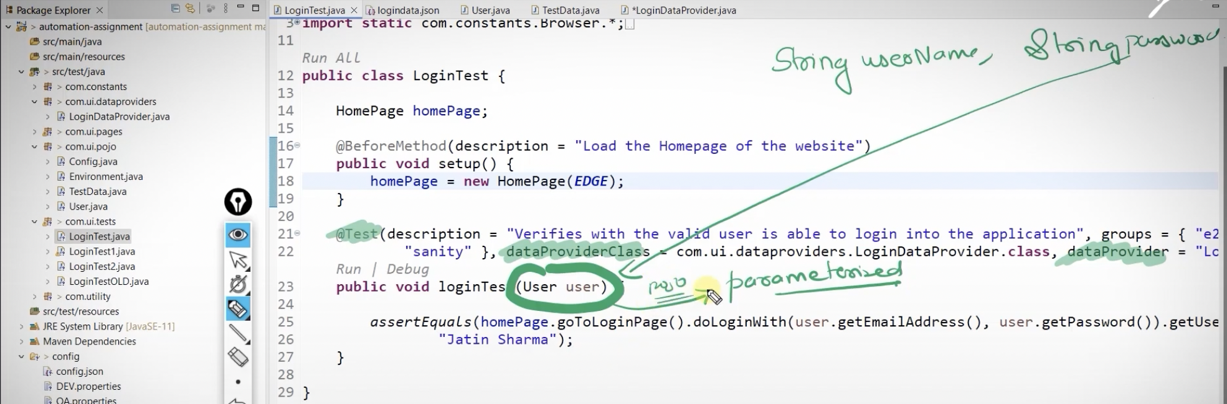

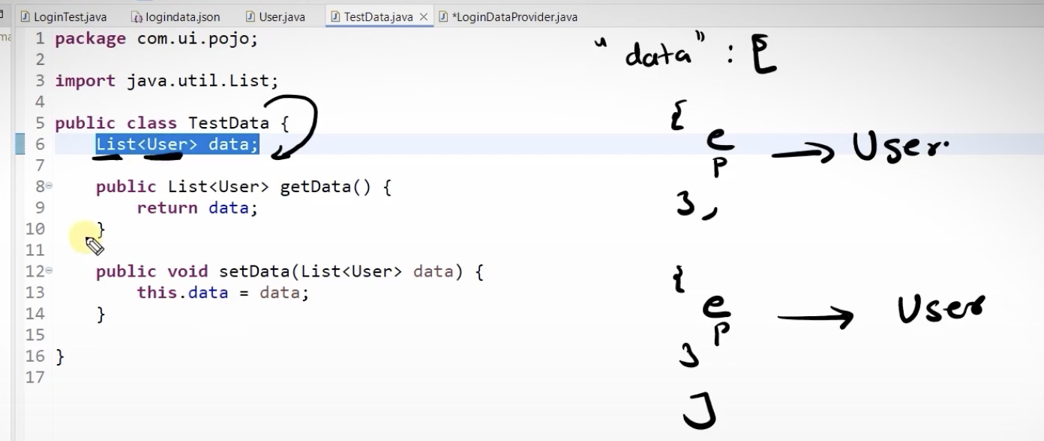

List<Object[]> dataToReturn = new ArrayList<Object[]>(); Why not   
ArrayList<Object[]> dataToReturn = new ArrayList<Object[]>();

We always create reference variables for the parent classes and object of the child class. Here parent class is List and child class is ArrayList

TestData data =gson.fromJson(fileReader, TestData.class);  
This is **deserialization**, here we are creating a json object to java object

**List<Object[]> dataToReturn = new ArrayList<Object[]>();  
 for(User user:data.getData()){  
 dataToReturn.add(new Object[] {user});  
 }  
  
 return dataToReturn.iterator();  
  
 }**

In this code we will be getting the data one by one and then adding it to the arraylist and then finally returning the iterator.

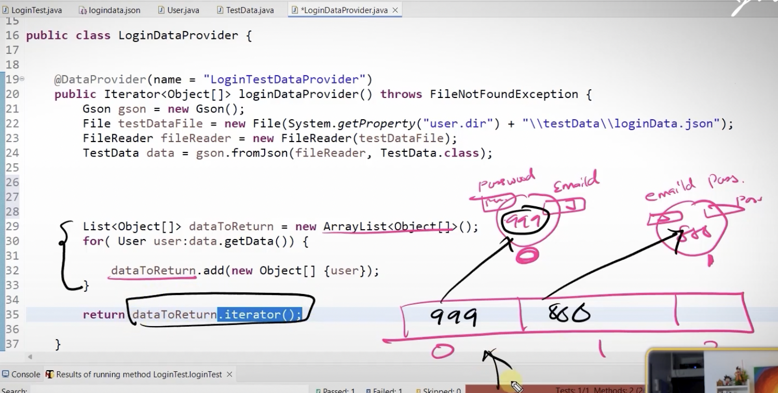

1. **CSV File**

We use **opencsv** library to read data from csv file in java

Excel uses tab as delimiter for separating columns, but csv file used comma as delimiter to separate columns

Best practices

In try catch block: Always do the declaration above the try and do the object creation/ assignment inside the try catch

Never read variable inside the loop, declare it outside the loop

csvReader.readNext() – returns null when there is no data available i.e no row or when we have reached the end of csv file

**while((data=csvReader.readNext())!=null){**

Here data=csvReader.readNext()is the initialisation and check whether the its not null, i.e it checks whether the last row of the csv file has reached

**public class CSVReaderUtility {  
  
 public static Iterator<User> readCSVFile(String fileName) {  
 File file = new File(System.*getProperty*("user.dir") + "/testData/" +fileName);  
 FileReader fileReader = null;  
 CSVReader csvReader;  
 String[] line;  
 List<User> userList = null;  
 User userData;  
 try {  
 fileReader = new FileReader(file);  
 csvReader = new CSVReader(fileReader);  
 csvReader.readNext();*// Reading the column names which is the row1, which not relevant to us* userList = new ArrayList<User>();  
 while ((line = csvReader.readNext()) != null) {  
 userData = new User(line[0], line[1]);  
 userList.add(userData);  
 }  
 } catch (FileNotFoundException e) {  
 e.printStackTrace();  
 } catch (IOException | CsvValidationException e) {  
 e.printStackTrace();  
  
 }  
 return userList.iterator();  
 }  
  
}**

In this method we can read the entire csv file to an arraylist

1. **Excel File**

External library : apache poi  
**public class ExcelReaderUtility {  
  
 public static Iterator<User> readExcelFile(String fileName) {  
  
 File xlsxfile = new File(System.*getProperty*("user.dir") + "/testData/"+fileName);  
 *///XLS file* XSSFWorkbook xssfWorkbook= null;  
 List<User> userList=null;  
 User user;  
 Row row;  
 Cell emailAddressCell,passwordCell;  
 XSSFSheet xssfSheet;  
 try {  
 xssfWorkbook = new XSSFWorkbook(xlsxfile);  
 userList= new ArrayList<User>();  
 xssfSheet=xssfWorkbook.getSheet("LoginTestData");  
 Iterator<Row> rowIterator=xssfSheet.iterator();  
 rowIterator.next(); *// to skip the column name* while (rowIterator.hasNext()){  
 row=rowIterator.next();  
 emailAddressCell=row.getCell(0);  
 passwordCell=row.getCell(1);  
 user=new User(emailAddressCell.toString(),passwordCell.toString());  
 userList.add(user);  
 xssfWorkbook.close();  
  
 }  
 } catch (IOException e) {  
 e.printStackTrace();  
 } catch (InvalidFormatException e) {  
 e.printStackTrace();  
 }  
  
 return userList.iterator();  
 }  
}**

**Re-run failed test cases**

Interface : acts like a parent entity, so if we are not sure what we need to write inside a class then on implementing interface it will guide you what we need to write inside the class and the implementation should be done by the child class. So whenenver we want to write some extra rules then we need to make use of interface

**IRetryAnalyzer :** is a interface used in the automation framework for retry mechanism

**public boolean retry(ITestResult result) {  
  
 return false;  
}**Here **ITestResult** stores the info about the tests like the name of the test, groups, the description, status of the test like failed, passed etc..  
Here ITestResult stores the info regarding the failed tests in particular because its called in the retry method.   
**Retry** method is called when the testcase fails. If it returns true, then rerun the failed test. If its false, then the TestNG marks the test case as failed

Also specify the maximum number of attempts we need to retry if the test fails   
  
**public class MyRetryAnalyser implements IRetryAnalyzer {  
  
 private static final int *MAX_NUMBER_OF_ATTEMPTS* =3;  
 private static int *currentAttempt*=1;  
 @Override  
 public boolean retry(ITestResult result) {  
 if(*currentAttempt*<=*MAX_NUMBER_OF_ATTEMPTS*){  
 *currentAttempt*++;  
 return true;  
 }  
  
 return false;  
 }  
}**

Another way to run the failed test cases is using testing-failed.xml file  
In a case were we are running 700 testcases in Jenkins and out of that 150 failed. How to run the failed test cases alone in the next Jenkins run  
In this case we need to configure the Jenkins job in such a way that next time the testng-failed.xml file is executed  
In the case of retry analyser the execution of the failed tests happens in the run time, but the testing-failed.xml file stores the failed test details and later we can execute it

**Adding Logs into the Automation Framework**

**Why custom logging is required even though we have console logging already generated?**  
This is because as our automation framework become complicated and we add more components to it , it will be difficult to debug the issue from the logging generated from the java libraries so we in order to debug and find the issues that are happening in the automation framework and fix them fast

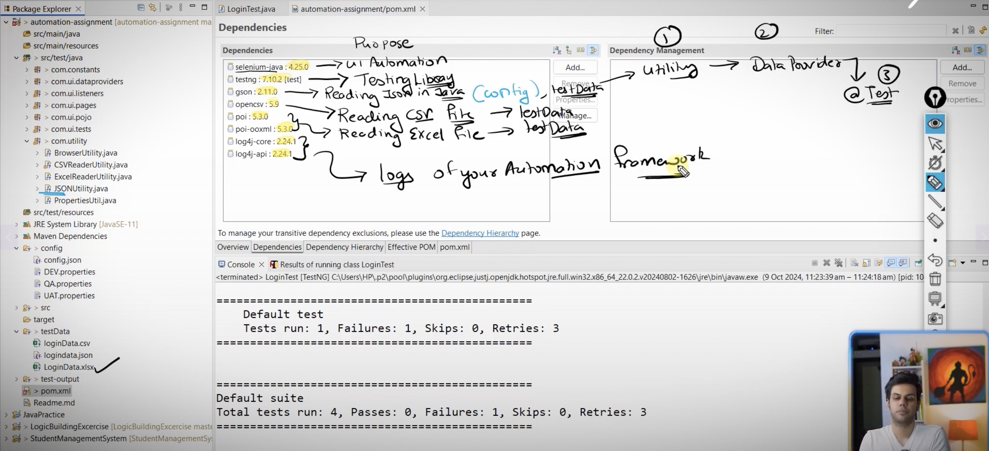

***<?*xml version="1.0" encoding="UTF-8" *?>*<Configuration>  
 <Appenders>  
 <Console name="Console" target="SYSTEM_OUT">  
  
 <PatternLayout pattern="%d{YYYY-MM-dd HH:mm:ss} [%t] %level %logger %msg %n"></PatternLayout>  
 </Console>  
  
 <File name="FileLogger" fileName="logs/automation.log" append="false"></File>  
 <PatternLayout pattern="%d{YYYY-MM-dd HH:mm:ss} [%t] %level %logger %msg %n"></PatternLayout>  
  
 </Appenders>  
  
 <Loggers>  
 <Root leve="info">  
 <AppenderRef ref="Console"></AppenderRef>  
 <AppenderRef ref="FileLogger"></AppenderRef>  
  
  
 </Root>  
 </Loggers>  
</Configuration>**

Here there are 2 main sections  
1. Appenders : decide where to store the logs. This can be either in   
Console  
<Console name="Console" target="SYSTEM_OUT">  
 <PatternLayout pattern="%d{YYYY-MM-dd HH:mm:ss} [%t] %level %logger %msg %n"></PatternLayout>  
</Console>

Here the console name is “Console” and the pattern %d : timestamp, %t : thread 🡪 which class %level – logging level %logger : exact method of logging %msg : message %n – new line  
  
File  
<File name="FileLogger" fileName="logs/automation.log" append="false"></File>  
<PatternLayout pattern="%d{YYYY-MM-dd HH:mm:ss} [%t] %level %logger::%M::%L %msg %n"></PatternLayout>  
Here the file name is “FileLogger” and the logs are stored in logs/automation.log and append =false means the new logs should not be appended with the old one

%M : denotes method name

%L : denotes the line number

Loggers : It has the root level of logs and also the appender references  
<Loggers>  
 <Root level="info">  
 <AppenderRef ref="Console"></AppenderRef>  
 <AppenderRef ref="FileLogger"></AppenderRef>  
 </Root>  
</Loggers>

If the level is set as info, the logger captures all the levels from info to fatal

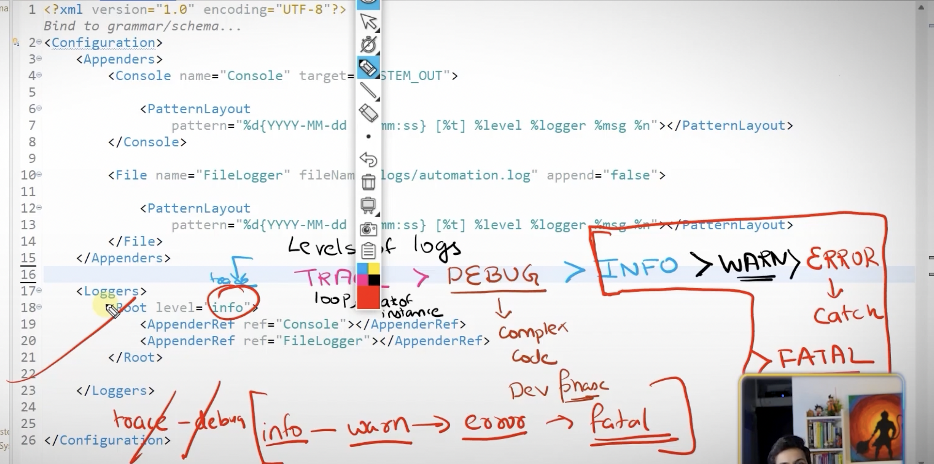

Trace : loop, state of instance, every granular details of the application

Debug : complex code, in development phase

Info: execution of methods

Warn : File opened and not closed, not the issues in the application

Error : try catch exception, test failures

Fatal : unable to connect to data base

How to ensure that you are implemented OOPs concept in the right way

By making use of Design Patterns:

1. POJO
2. Page Object Model
3. Singleton Design pattern

Singleton Design pattern : Ensures that you will have only one object created for the class. It’s basically used in DB connectivity, Logger utility

Static keyword is used to make sure that only one memory is allocated

In singleton class we should have private constructor. This means we can only create the object of the class inside the same class and not possible to create outside the class

If the constructor is private, so we can create only one object of the class and even if we want to access the methods in the class, outside of the class then we need to mark the method as static. So **getLogger** is marked as static

Using the **getLogger** method the object of the logger class will be created inside the class  
  
**public class LoggerUtility {  
  
 private static Logger *logger*;  
  
 private LoggerUtility() {  
 }  
  
 public Logger getLogger(Class<?> clazz){  
 if(*logger*==null) { *// when first time when we are creating an object then only the object will be created i.e. if the logger is null then onlt the object will be initialised else the same refernce will be called again  
 logger* = LogManager.*getLogger*(clazz);  
 }  
 return *logger*;  
 }  
}**

**private static Logger logger;**  
This will generate output as below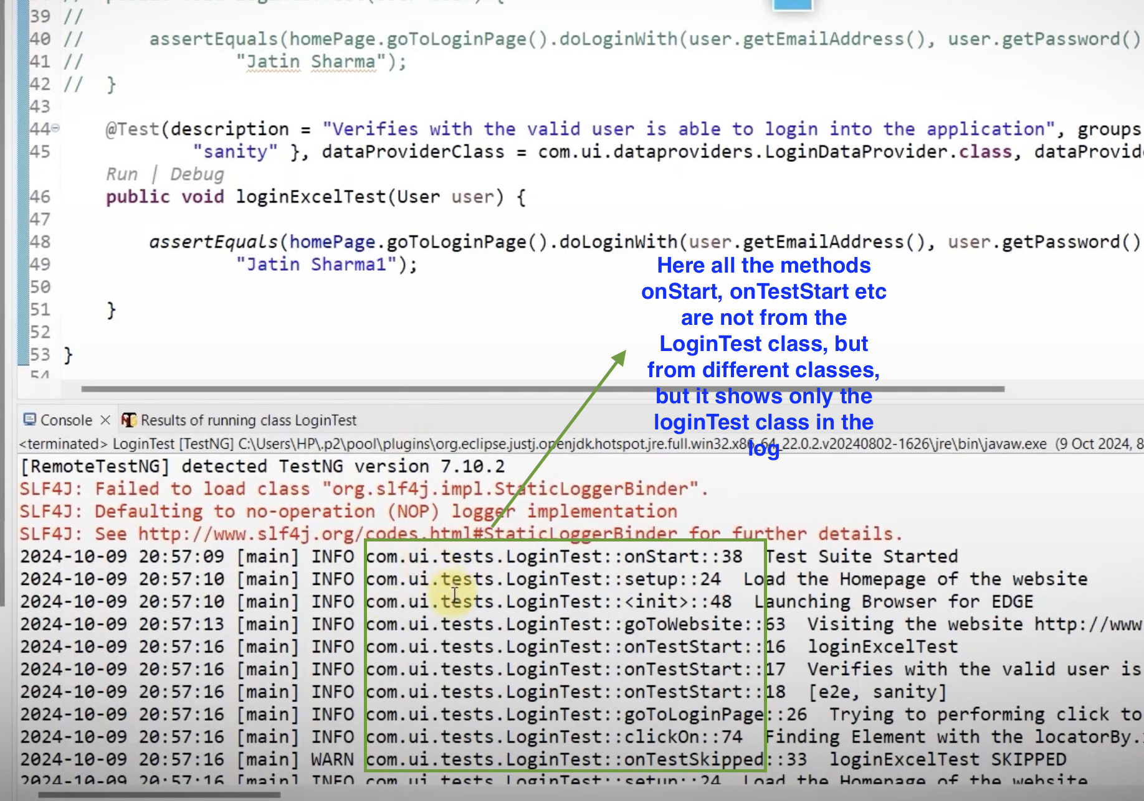

So in order to fix this issue modify the code as below, change the static variable to a local variable, so that each class should have the respective loggers  
  
**public class LoggerUtility {  
  
 private LoggerUtility() {  
 }  
  
 public static Logger getLogger(Class<?> clazz){  
 Logger logger=null;  
 if(logger==null) { *// when first time when we are creating an object then only the object will be created i.e. if the logger is null then onlt the object will be initialised else the same refernce will be called again* logger = LogManager.*getLogger*(clazz);  
 }  
 return logger;  
 }  
}**

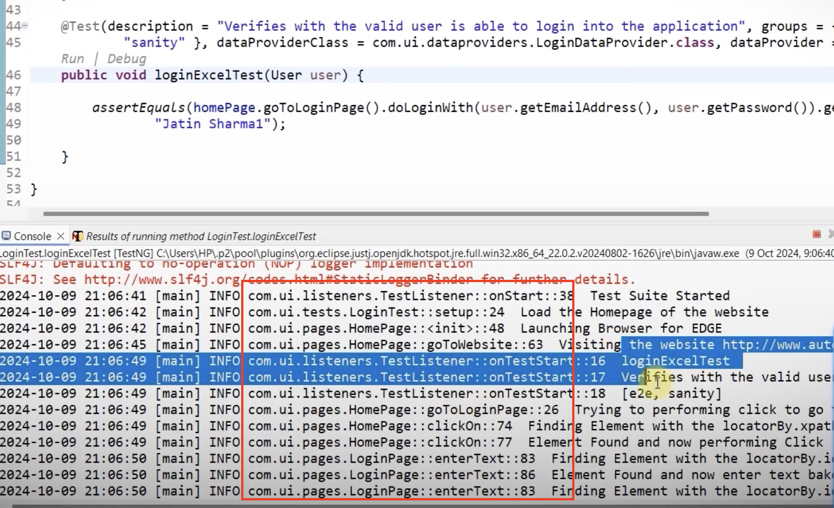

**ITestListener** Its an interface and

Interfaces can have abstract methods and non-abstract methods. Interface can also have complete method body. In Java 8 this feature was introduced, because if the child class does not want to implement any method, then default method can be implemented in the child class from the interface.

It’s not always required to implement all the methods in the interface. We can select the methods which needs to be implemented from the interface.

**public class TestListener implements ITestListener {  
 Logger logger= LoggerUtility.*getLogger*(this.getClass());  
  
 public void onTestStart(ITestResult result) {  
 logger.info(result.getMethod().getMethodName());  
 logger.info(result.getMethod().getDescription());  
 logger.info(Arrays.*toString*(result.getMethod().getGroups()));  
 }  
  
 public void onTestSuccess(ITestResult result) {  
 logger.info(result.getMethod().getMethodName()+" "+"PASSED");  
 }  
  
 public void onTestFailure(ITestResult result) {  
 logger.error(result.getMethod().getMethodName()+" "+"FAILED");  
  
 }  
 public void onTestSkipped(ITestResult result) {  
 logger.info(result.getMethod().getMethodName()+" "+"SKIPPED");  
 }  
  
 public void onStart(ITestContext context) {  
 logger.info("Test suite started");  
 }  
  
 public void onFinish(ITestContext context) {  
 logger.info("Test suite completed");  
  
 }  
  
}**

**Generate extent report for the automation framework**

There are 3 classes for integrating the extent report  
In the TestListener class create the reference variables of these 3 classes  
 **ExtentSparkReporter extentSparkReporter;**To provide the functionality to create the html file, the styling, look of the html file **ExtentReports extentReports;**To do the heavy lifting, the data that needs to be dumped in to the html file and creates the html file **ExtentTest extentTest;**

To store the information about the test, like which test started, completed etc

**public class TestListener implements ITestListener {  
 Logger logger= LoggerUtility.*getLogger*(this.getClass());  
  
 ExtentSparkReporter extentSparkReporter;  
 ExtentReports extentReports;  
 ExtentTest extentTest;  
  
 public void onTestStart(ITestResult result) {  
 logger.info(result.getMethod().getMethodName());  
 logger.info(result.getMethod().getDescription());  
 logger.info(Arrays.*toString*(result.getMethod().getGroups()));  
 extentTest= extentReports.createTest(result.getMethod().getMethodName());  
 }  
  
 public void onTestSuccess(ITestResult result) {  
 logger.info(result.getMethod().getMethodName()+" "+"PASSED");  
 extentTest.log(Status.*PASS*,result.getMethod().getMethodName()+" "+"PASSED");  
 }  
  
 public void onTestFailure(ITestResult result) {  
 logger.error(result.getMethod().getMethodName()+" "+"FAILED");  
 extentTest.log(Status.*FAIL*,result.getMethod().getMethodName()+" "+"FAILED");  
  
  
 }  
 public void onTestSkipped(ITestResult result) {  
 logger.info(result.getMethod().getMethodName()+" "+"SKIPPED");  
 extentTest.log(Status.*SKIP*,result.getMethod().getMethodName()+" "+"SKIPPED");  
  
 }  
  
 public void onStart(ITestContext context) {  
 logger.info("Test suite started");  
 extentSparkReporter=new ExtentSparkReporter(System.*getProperty*("user.dir")+"\report.html");  
 extentReports=new ExtentReports();  
 extentReports.attachReporter(extentSparkReporter);  
 }  
  
 public void onFinish(ITestContext context) {  
 logger.info("Test suite completed");  
 extentReports.flush(); *// only now the data will be flushed to the html file and the report will be created* }  
  
}**

But thisapproach is not thread safe and a not a good approach while running the tests in parallel mode, so a custom utility needs to be created

**ThreadLocal**The purpose ofThreadLocal is to ensure thread safety and provides isolation, so other threads cannot access this variable and the values will not be corrupted, i.e. there will not be any illegal assignment

Why **private static ExtentReports *extentReports*;**   
Even if we have multiple tests running we need to create a single exten report

**private static ExtentTest *extentTest*;**

Here there is single memory allocation, but when we consider parallel execution, it should be modified as   
**private ThreadLocal<ExtentTest> extentTest= new ThreadLocal<ExtentTest>();**

Here a local variable for individual thread for ExtentTest and object of the Threadlocal is created  
**extentTest:** holds the info of each @Test method, i.e why its marked as threadlocal

**public class TestListener implements ITestListener {  
 Logger logger= LoggerUtility.*getLogger*(this.getClass());  
  
 ExtentSparkReporter extentSparkReporter;  
 ExtentReports extentReports;  
 ExtentTest extentTest;  
  
 public void onTestStart(ITestResult result) {  
 logger.info(result.getMethod().getMethodName());  
 logger.info(result.getMethod().getDescription());  
 logger.info(Arrays.*toString*(result.getMethod().getGroups()));  
 ExtentReportUtility.*createExtentTest*(result.getMethod().getMethodName());  
 }  
  
 public void onTestSuccess(ITestResult result) {  
 logger.info(result.getMethod().getMethodName()+" "+"PASSED");  
  
 ExtentReportUtility.*getTest*().log(Status.*PASS*,result.getMethod().getMethodName()+" "+"PASSED");  
 }  
  
 public void onTestFailure(ITestResult result) {  
 logger.error(result.getMethod().getMethodName()+" "+"FAILED");  
 logger.error(result.getThrowable().getMessage());  
 ExtentReportUtility.*getTest*().log(Status.*FAIL*,result.getMethod().getMethodName()+" "+"FAILED");  
  
  
 }  
 public void onTestSkipped(ITestResult result) {  
 logger.info(result.getMethod().getMethodName()+" "+"SKIPPED");  
 ExtentReportUtility.*getTest*().log(Status.*SKIP*,result.getMethod().getMethodName()+" "+"SKIPPED");  
  
 }  
  
 public void onStart(ITestContext context) {  
 logger.info("Test suite started");  
 ExtentReportUtility.*setupSparkReporter*("report.html");  
  
 }  
  
 public void onFinish(ITestContext context) {  
 logger.info("Test suite completed");  
 ExtentReportUtility.*flushReport*(); *// only now the data will be flushed to the html file and the report will be created* }  
  
}**

**Creating TestNG xml file**

<!DOCTYPE suite SYSTEM "https://testng.org/testng-1.0.dtd"*>*<suite name="Automation Practice Test Suite" parallel="methods" thread-count="4" verbose="1">  
 <test name="UI Automation Test">  
 <classes>  
 <class name="com.ui.tests.LoginTest"/>  
 </classes>  
 </test>  
</suite>

For parallel execution we use parallel="methods" thread-count="4"

**Taking Screenshot for failed test cases**

Interface : TakeScreenshot

**Note : Static methods can only access static variables

**What are the steps to follow to access the BrowserUtility takeScreenshot method in the TestListener class**

1. Child of BrowserUtility is the Page classes, i.e. HomePage is a child of BrowserUtility. So HomePage can invoke all the methods of BrowserUtility without creating the object (inheritance)
2. In the LoginTest class, under setup method we are creating the object of the HomePage
3. The first object that’s created will be the HomePage object irrespective of what tests we are going to execute
4. Create a ‘TestBase’ class which is the parent of the LoginTest class and all the test classes. So whenever we are going to create a test class we need to extend the TestBase class

**public class LoginTest2 extends TestBase**

1. **TestBase class  
     
   public class TestBase {  
    protected HomePage homePage; *// protected because it will be accessible in the child classes* Logger logger= LoggerUtility.*getLogger*(this.getClass());  
     
    @BeforeMethod(description = "Load the homePage of the website")  
    public void setUp() {  
    logger.info("Load the home page of the website");  
    homePage = new HomePage(*CHROME*);  
     
    }  
     
    public BrowserUtility getInstance(){  
    return homePage;  
    }  
   }**
2. When ever we are returning an object reference of a child class, the make sure that the return type is parent class reference

**public BrowserUtility getInstance(){  
 return homePage;  
}**

**TestListener Class  
public void onTestFailure(ITestResult result) {  
 logger.error(result.getMethod().getMethodName()+" "+"FAILED");  
 logger.error(result.getThrowable().getMessage());  
 ExtentReportUtility.*getTest*().log(Status.*FAIL*,result.getMethod().getMethodName()+" "+"FAILED");  
 ExtentReportUtility.*getTest*().log(Status.*FAIL*,result.getThrowable().getMessage());  
 Object testClass=result.getInstance(); // It gives the object instance of the test class  
 BrowserUtility browserUtility=((TestBase)testClass).getInstance();// browserUtility refernce is created in the TestListener class to access the takeScreenShot method. Here all the child classes are casted to the TestBase inorder to access the method from the TestBase i.e the getInstance() method  
 logger.info("Capturing screenshot for failed tests");  
 String screenshotPath=browserUtility.takeScreenShot(result.getMethod().getMethodName());  
 logger.info("Attaching screenshot to HTML file");  
 ExtentReportUtility.*getTest*().addScreenCaptureFromPath(screenshotPath);  
  
}**

**Running tests in Headless mode**

Create another constructor for the BrowserUtility with parameter isHeadless as below  
**public BrowserUtility(Browsers browserName, boolean isHeadless) {  
 if (browserName == Browsers.*CHROME*) {  
 if (isHeadless) {  
 ChromeOptions options = new ChromeOptions();  
 options.addArguments("--headless=old");*// if --headless=old is given because otherwise a wilte screen will be shown, this is to launch the browser in headless mode* options.addArguments("--window-size=1920,1080");*//to execute in full screen mode  
 driver*.set(new ChromeDriver(options));  
 } else {  
 *driver*.set(new ChromeDriver());  
 }  
 } else if (browserName == Browsers.*EDGE*) {  
 if (isHeadless) {  
 EdgeOptions options = new EdgeOptions();  
 options.addArguments("--headless=old");*// if --headless=old is given because otherwise a white screen will be shown, this is to launch the browser in headless mode* options.addArguments("disable-gpu");*// if headless is not working to make sure that the browser is not launched  
 driver*.set(new EdgeDriver(options));  
 } else {  
 *driver*.set(new EdgeDriver());  
 }  
}**

**else if (browserName == Browsers.*FIREFOX*) {  
 if (isHeadless) {  
 FirefoxOptions options = new FirefoxOptions();  
 options.addArguments("--headless=old");*// if --headless=old is given because otherwise a wilte screen will be shown, this is to launch the browser in headless mode  
 driver*.set(new FirefoxDriver(options));  
 } else {  
 *driver*.set(new FirefoxDriver());  
 }  
 }  
}**

**Integrating LambdaTest in Automation Framework**

Create an account in lamdatest

1. Create a class named LambdaTestUtility which contains threadlocal DesiredCapabilities, threadlocal webdriver of each test and also instantiating the driver  
   Always make sure that tests are run in parallel mode, we need to make it thread safe and each session should be isolated from each other
2. Copy the desired capabilities from the lambdatest sample project and then paste it in the LambdaTestUtility class and create 2 variables browser and testName as parameters
3. **private static ThreadLocal<WebDriver> *driverLocal*=new ThreadLocal<WebDriver>();  
   private static ThreadLocal<DesiredCapabilities> *capabilitiesLocal* = new ThreadLocal<DesiredCapabilities>();**Create thread safe driver and desired capabilities
4. ***capabilitiesLocal*.set(capabilities);** //attaching the capabilities to the ThreadLocal capabilities
5. **WebDriver driver = null;  
   try {  
    driver = new RemoteWebDriver(new URL(*HUB_URL*), *capabilitiesLocal*.get());  
   } catch (MalformedURLException e) {  
    e.printStackTrace();  
   }  
   *driverLocal*.set(driver);** // Create the remote driver instance and attach it to the thread local driver
6. Make the function return Webdriver instance **return *driverLocal*.get();**

**public class LambdaTestUtility {  
 public static final String *HUB_URL* = "https://hub.lambdatest.com/wd/hub";  
 private static ThreadLocal<WebDriver> *driverLocal*=new ThreadLocal<WebDriver>();  
 private static ThreadLocal<DesiredCapabilities> *capabilitiesLocal* = new ThreadLocal<DesiredCapabilities>();  
  
 public static WebDriver initializeLambdaTestSession(String browser, String testName) {  
 DesiredCapabilities capabilities = new DesiredCapabilities();  
 capabilities.setCapability("browserName", browser);  
 capabilities.setCapability("browserVersion", "127");  
 Map<String, Object> ltOptions = new HashMap();  
 ltOptions.put("user", System.*getenv*("meeramanilal"));  
 ltOptions.put("accessKey", System.*getenv*("LT_H5gL14hcqEhuMVoH4JXyLWxASWaExbwjCt3y3Kk98cyTif4"));  
 ltOptions.put("build", "Selenium 4");  
 ltOptions.put("name",testName);  
 ltOptions.put("platformName", "Windows 10");  
 ltOptions.put("seCdp", true);  
 ltOptions.put("selenium_version", "4.23.0");  
 capabilities.setCapability("LT:Options", ltOptions);  
 *capabilitiesLocal*.set(capabilities); *//attaching the capabilities to the ThreadLocal capabilities* WebDriver driver = null;  
 try {  
 driver = new RemoteWebDriver(new URL(*HUB_URL*), *capabilitiesLocal*.get());  
 } catch (MalformedURLException e) {  
 e.printStackTrace();  
 }  
 *driverLocal*.set(driver);  
 return *driverLocal*.get();  
 }  
  
}**

1. Create another method to quit the driver session  
   **public static void quitSession(){  
    if(*driverLocal*.get()!=null){  
    *driverLocal*.get().quit();  
    }  
   }**
2. Modify the code in TestBase class, Add a Boolean vaiable isLambdaTest and then if its true then initialise the LambdaTestSession and create a method of the homepage, for quitting the browser also call the quitSession() method in the LambdaTestUtility class

**public class TestBase {  
 protected HomePage homePage; *// protected because it will be accessible in the child classes* Logger logger= LoggerUtility.*getLogger*(this.getClass());  
 private boolean isLambdaTest=false;  
 private boolean isHeadless=true;  
 @BeforeMethod(description = "Load the homePage of the website")  
 public void setUp(ITestResult result) {  
 WebDriver lambdaDriver;  
 if (isLambdaTest) {  
 lambdaDriver = LambdaTestUtility.*initializeLambdaTestSession*("chrome", result.getMethod().getMethodName());  
 homePage=new HomePage(lambdaDriver);  
  
 } else {  
 logger.info("Load the home page of the website");  
 homePage = new HomePage(Browsers.*CHROME*, isHeadless);  
  
 }  
 }  
  
 public BrowserUtility getInstance(){  
 return homePage;  
 }  
  
 @AfterMethod(description = "Tear down the browser")  
 public void tearDown() {  
 if(isLambdaTest){  
 LambdaTestUtility.*quitSession*();  
 }else {  
 homePage.quit();  
 }  
 }  
}**

**TestNG Parameters**

If we want to run the test scripts from CI/CD, Jenkins we can make use of parameters

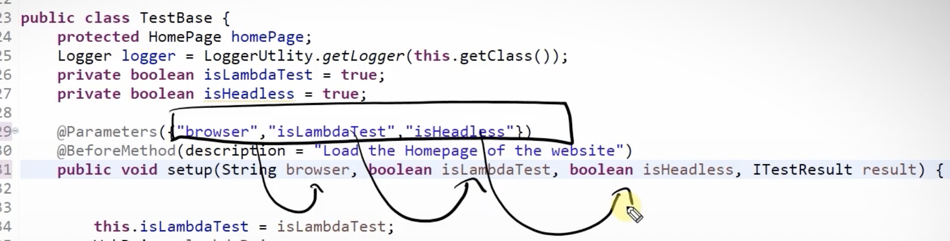

Make the following changes in testing.xml file

**<suite name="Automation Practice Test Suite" parallel="methods" thread-count="4" verbose="1">  
 <test name="UI Automation Test">  
 <parameter name="browser" value="chrome"></parameter>  
 <parameter name="isLambdaTest" value="false"></parameter>  
 <parameter name="isHeadless" value="true"></parameter>  
  
 <classes>  
 <class name="com.ui.tests.LoginTest2"/>  
 </classes>  
 </test>  
</suite>**

But in this case when we try to run it without the xml file just like a java application then we wont be able to run it as there are no parameters set, so inorder to avoid that error while running without testing.xml file we need to use @Optional  
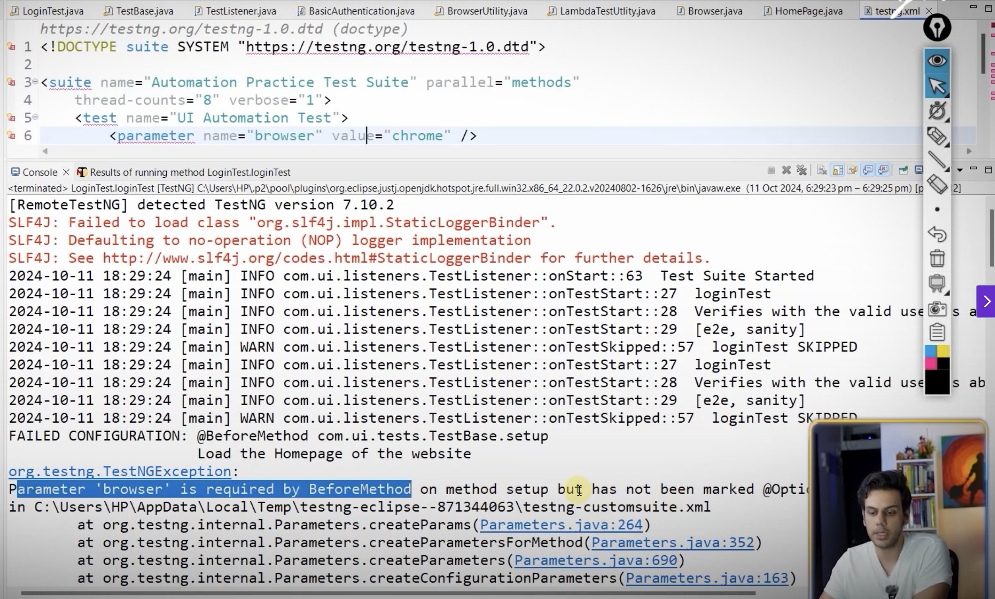

**public class TestBase {  
 protected HomePage homePage; *// protected because it will be accessible in the child classes* Logger logger= LoggerUtility.*getLogger*(this.getClass());  
 private boolean isLambdaTest;  
 @Parameters({"browser","isLambdaTest","isHeadless"})  
 @BeforeMethod(description = "Load the homePage of the website")  
 public void setUp(@Optional("chrome") String browser, //default value will be chrome if the parameter is not passed  
 @Optional("false") boolean isLambdaTest,  
 @Optional("true") boolean isHeadless, ITestResult result) {  
 this.isLambdaTest=isLambdaTest;**

**Maven Surefire Plugin**

This is used to pass the parameters from the terminal for executing the automation framework

In pom.xml file provide the **maven-surefire-plugin** plugin and then provide the testing.xml file and the parameters that we need to pass

**<build>  
 <plugins>  
 <plugin>  
 <groupId>org.apache.maven.plugins</groupId>  
 <artifactId>maven-surefire-plugin</artifactId>  
 <version>3.5.4</version>  
 <configuration>  
 <systemPropertyVariables>  
 <broswer>>firefox</broswer>  
 <isLambdaTest>false</isLambdaTest>  
 <isHeadless>true</isHeadless>  
 </systemPropertyVariables>  
 <suiteXmlFiles>  
 <suiteXmlFile>testng.xml</suiteXmlFile>  
 </suiteXmlFiles>  
 </configuration>  
 </plugin>  
 </plugins>  
</build>**

In order to access the parameters passed via pom.xml in testg.xml file modify the testng.xml as below  
  
 **<parameter name="browser" value="${broswer}"></parameter>  
 <parameter name="isLambdaTest" value="${isLambdaTest}"></parameter>  
 <parameter name="isHeadless" value="${isHeadless}"></parameter>**

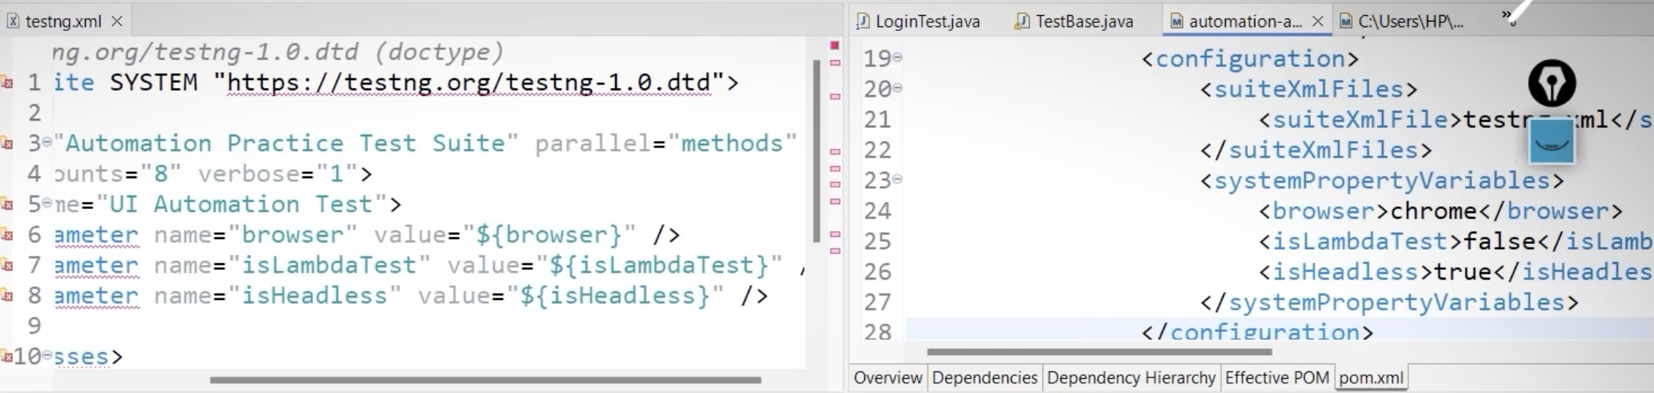

**How to run thru terminal**

**mvn test -X**

**To get the parameter do the modification in the pom.xml as below  
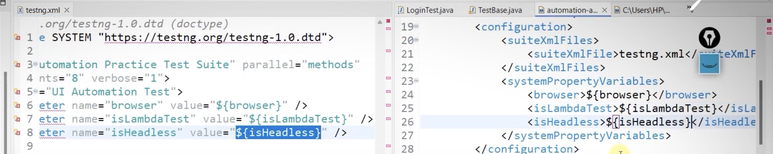**

**Then run the below command in terminal**

**mvn test -Dbrowser=chrome -DisLambdaTest=false -DisHeadless=true -X**

**-X for getting detailed logs**

**Running the test using Github Actions**

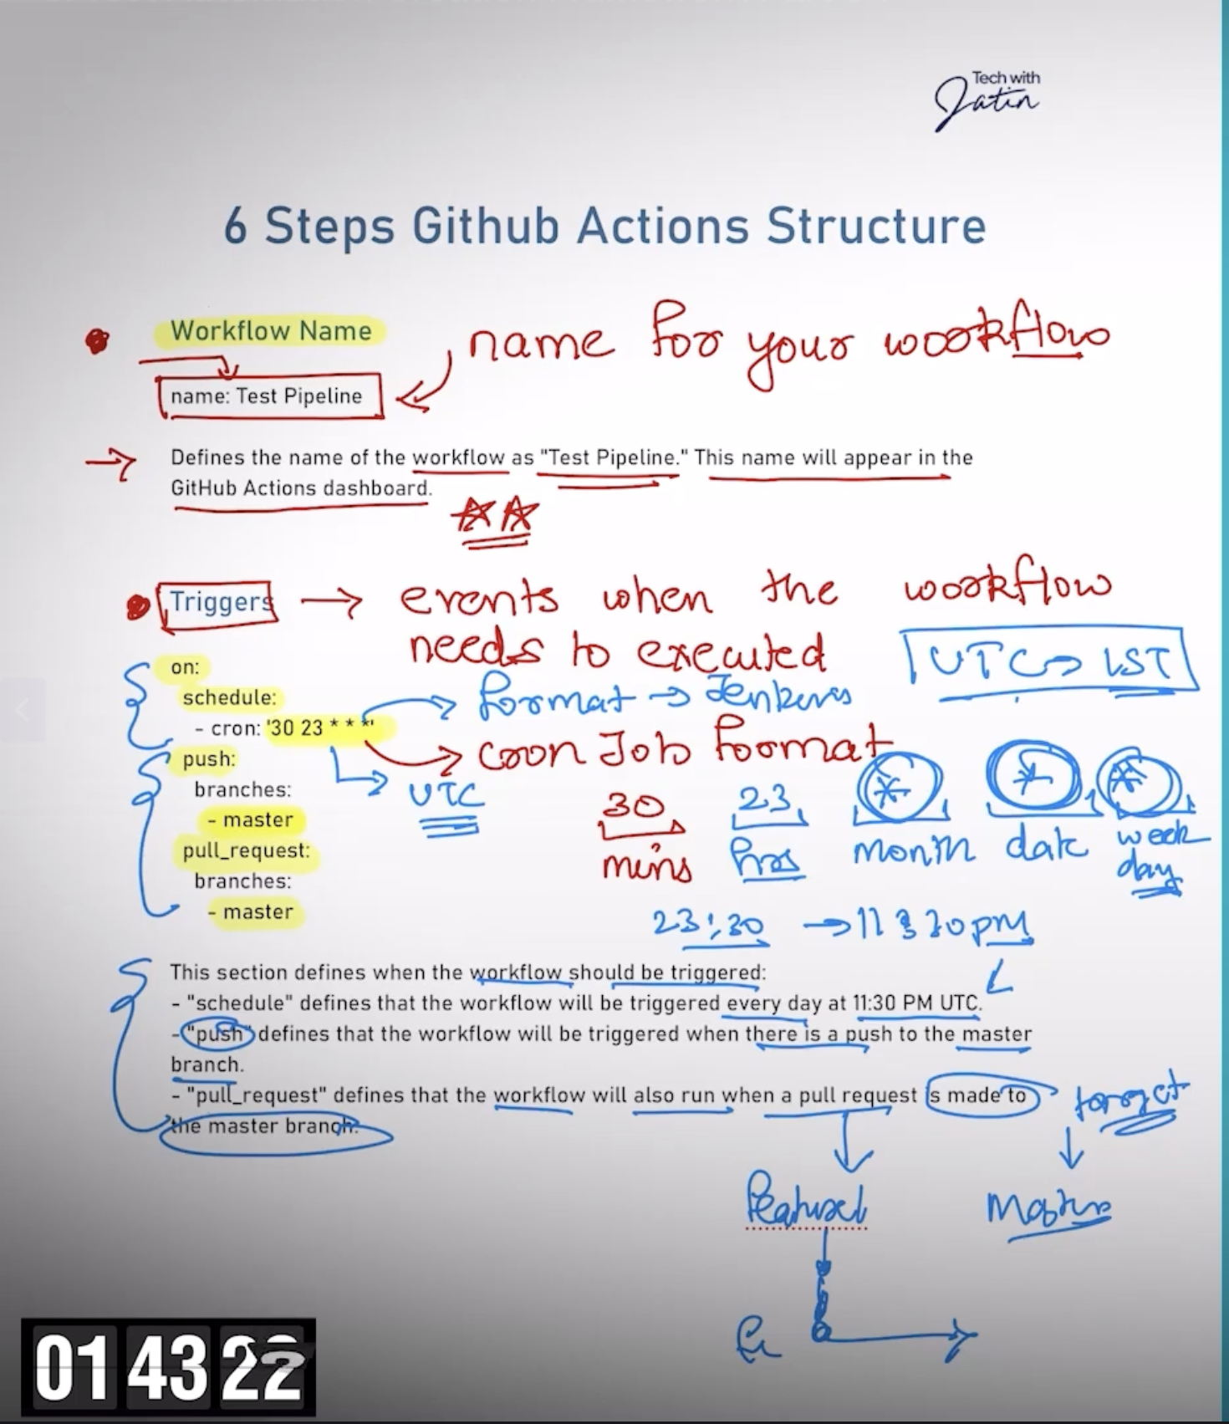

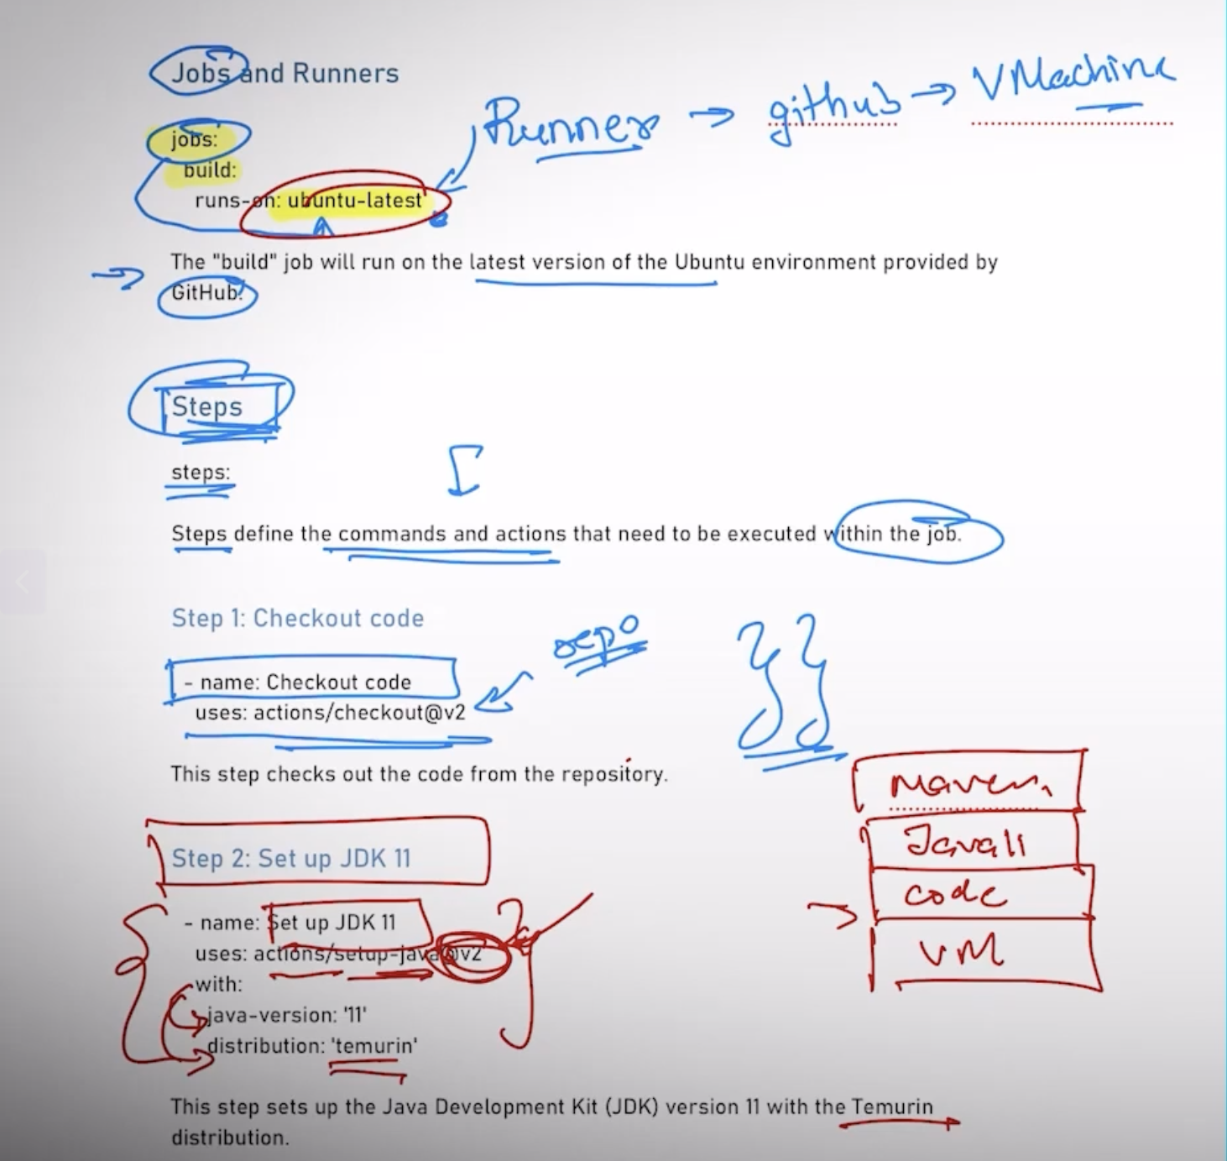

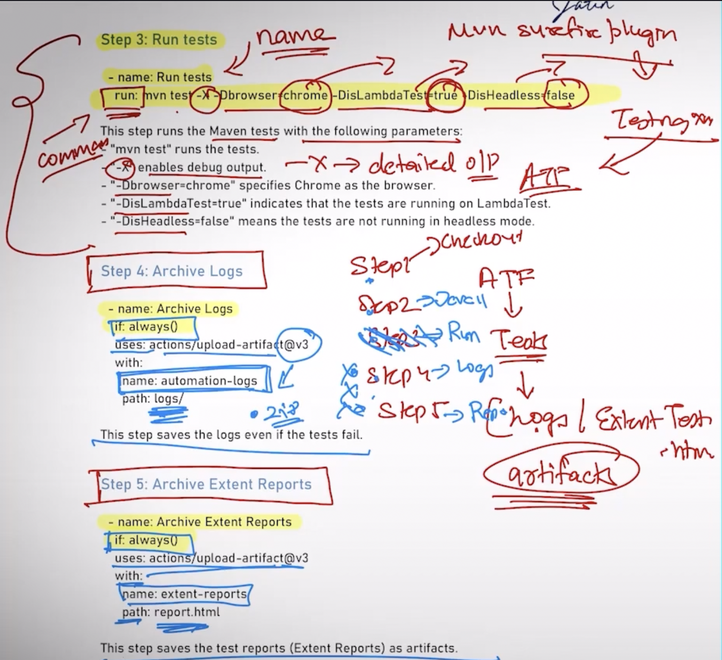

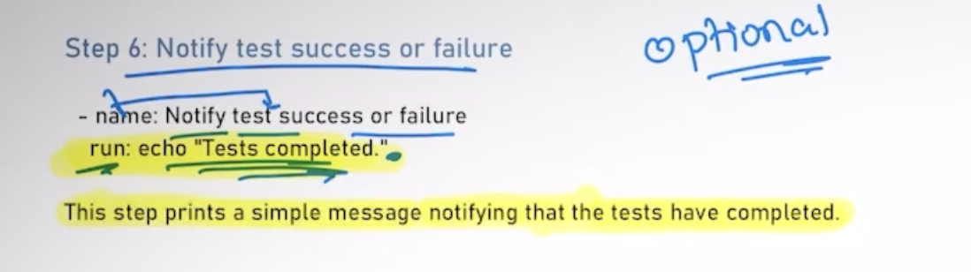

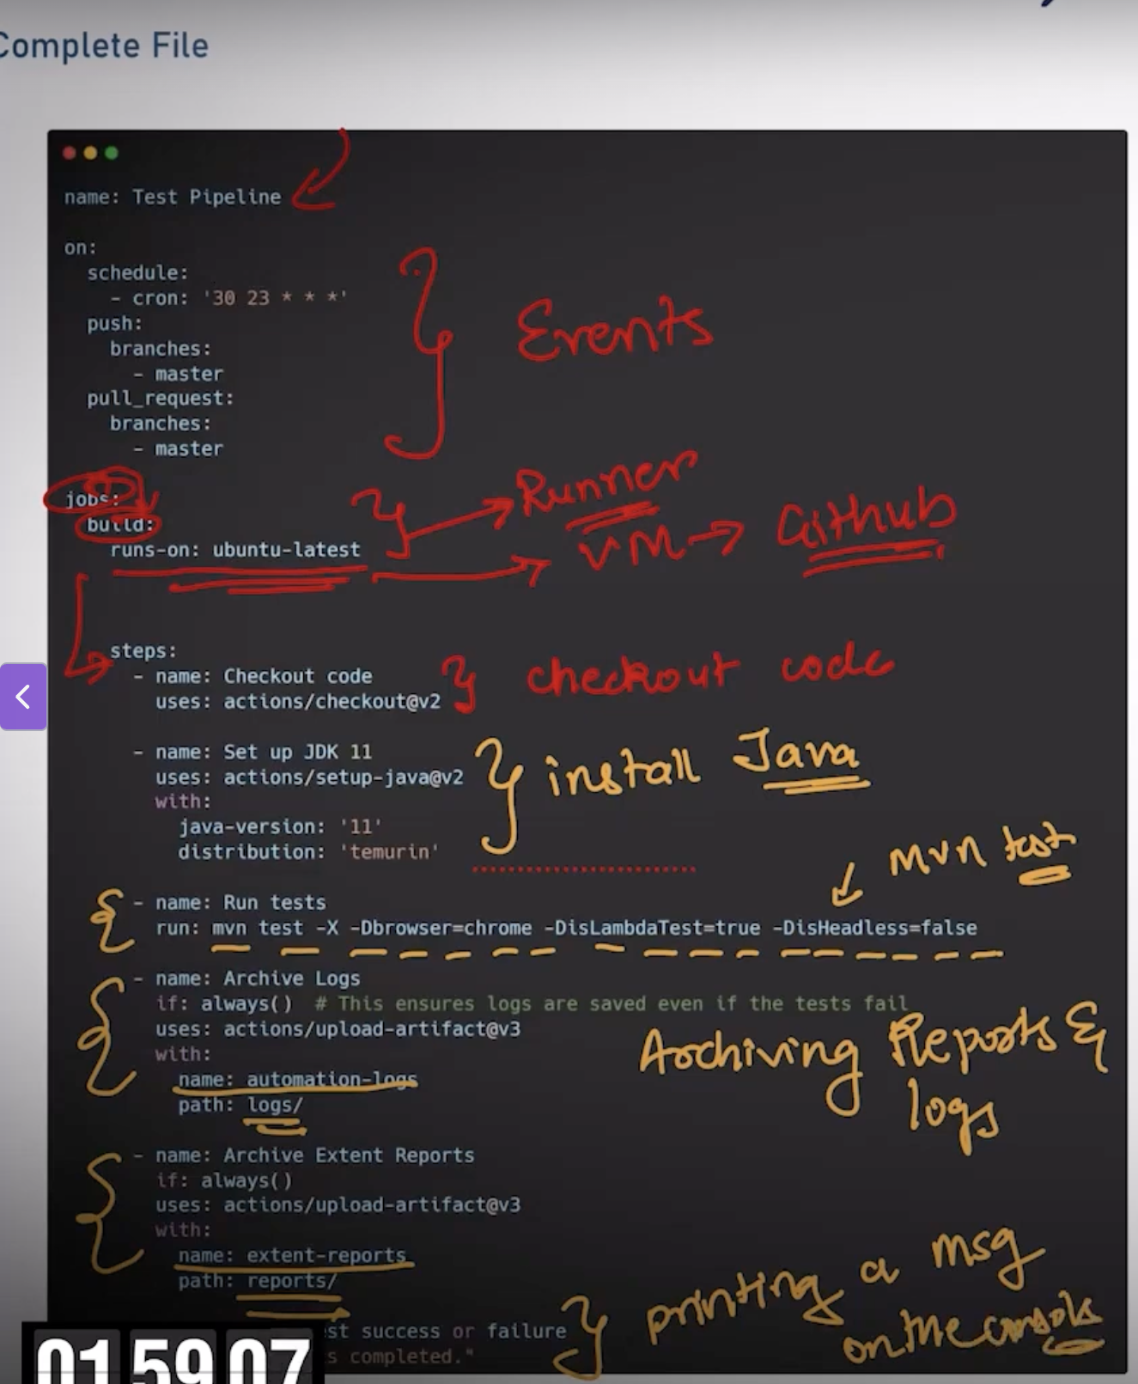

Challenges that we have face in automation framework

1. Coding the relative paths for screenshots and then only it will be correctly shown while executing remotely
2. Use forward slash for all the utilities like json,property files etc in the path, so that its acceptable in all OS’s
3. Instead of downloading the report, publish it as a html page, so that any one can access the report using an url

Maven.yml file

name: Test automation WorkFlow

on:

schedule:

- cron: '00 18 * * *'

push:

branches: [ "main" ]

pull_request:

branches: [ "main" ]

jobs:

build:

runs-on: ubuntu-latest

steps:

- uses: actions/checkout@v4

- name: Set up JDK 11

uses: actions/setup-java@v4

with:

java-version: '11'

distribution: 'temurin'

cache: maven

- name: Running test automation framework

run: mvn test -X -Dbrowser=chrome -DisLambdaTest=true -DisHeadless=false

- name: Upload Test logs

if: always()

uses: actions/upload-artifact@v4.6.2

with:

name: Test logs

path: logs/

- name: Upload Screenshots as Artifacts

if: always()

uses: actions/upload-artifact@v4.6.2

with:

name: screenshot

path: screenshots/

- name: Upload Test Reports as Artifacts

if: always()

uses: actions/upload-artifact@v4.6.2

with:

name: html-report

path: report.html

- name: Notify test sucess or failure

if: always()

run: echo "Test Execution Completed"

- name: Copy Report to gh-pages folder

if: always()

run:

mkdir -p public/extent-reports/

cp -R report.html public/extent-reports/

cp -R screenshots/ public/extent-reports/screenshots/

ls -l

- name: Deploy

if: always()

uses: JamesIves/github-pages-deploy-action@v4.7.3

with:

folder: public/extent-reports/

token: ${{ secrets.meerapat }}

clean: true

token: ${{ secrets.meerapat }}  
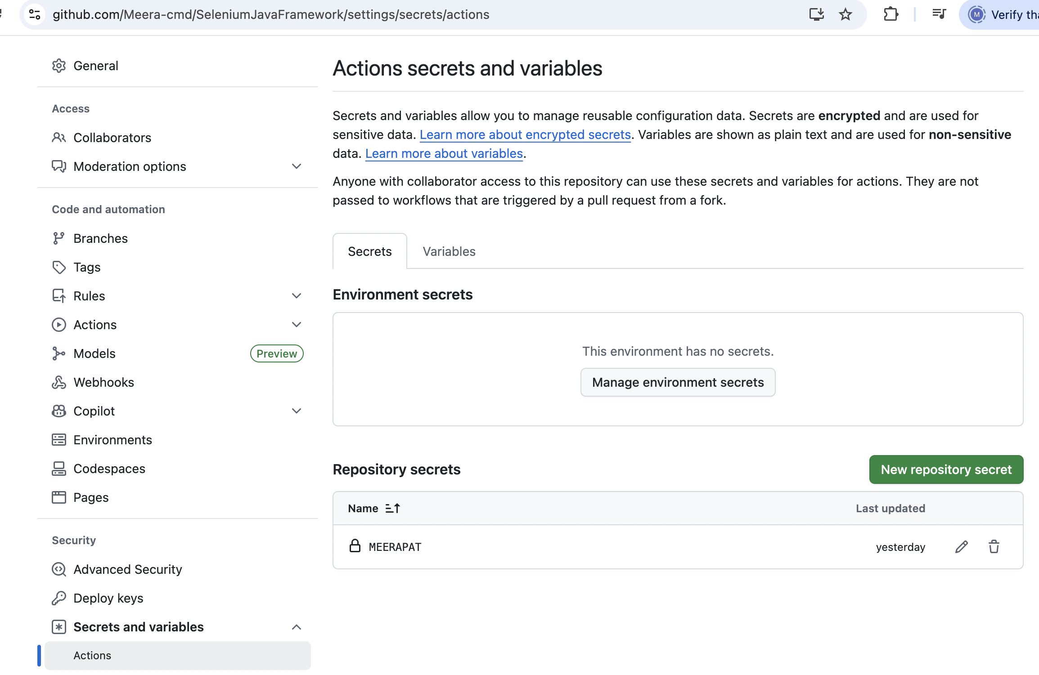

**Launching Jenkins on AWS EC2 instance**

1. Create an account in AWS
2. Create a server – high end for various computations in cloud
3. In AWS if I want to start a server then the service that is used is EC2 (Elastic commute)
4. Go to EC2 service > Launch an instance  
   Give the name of the server : Jenkins Server  
   Add additional tags : extra info abt the server like the if any installations like java,maven etc with their corr versions can be provided here  
   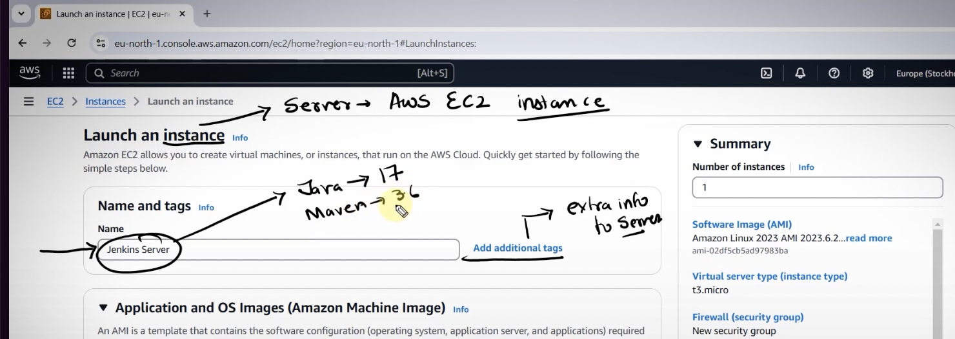
5. Select the OS : Ubuntu
6. Select the instance type as : m7i-flex.large
7. Create a new key pair, then a .pem file will be downloaded in the local machine  
     
   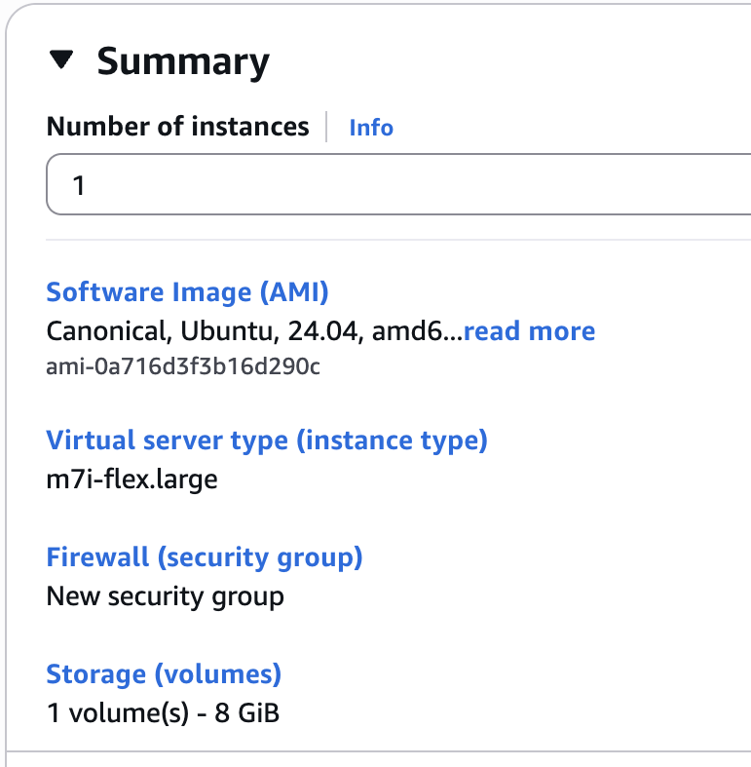
8. Launch the instance  
   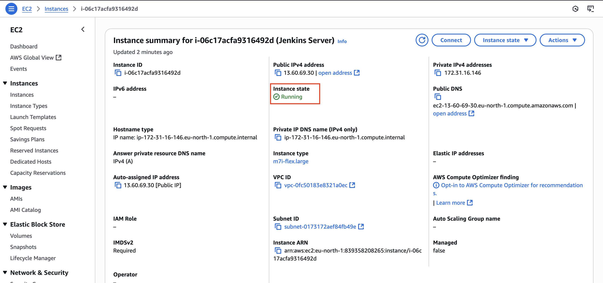
9. Connect to the server via SSH  
   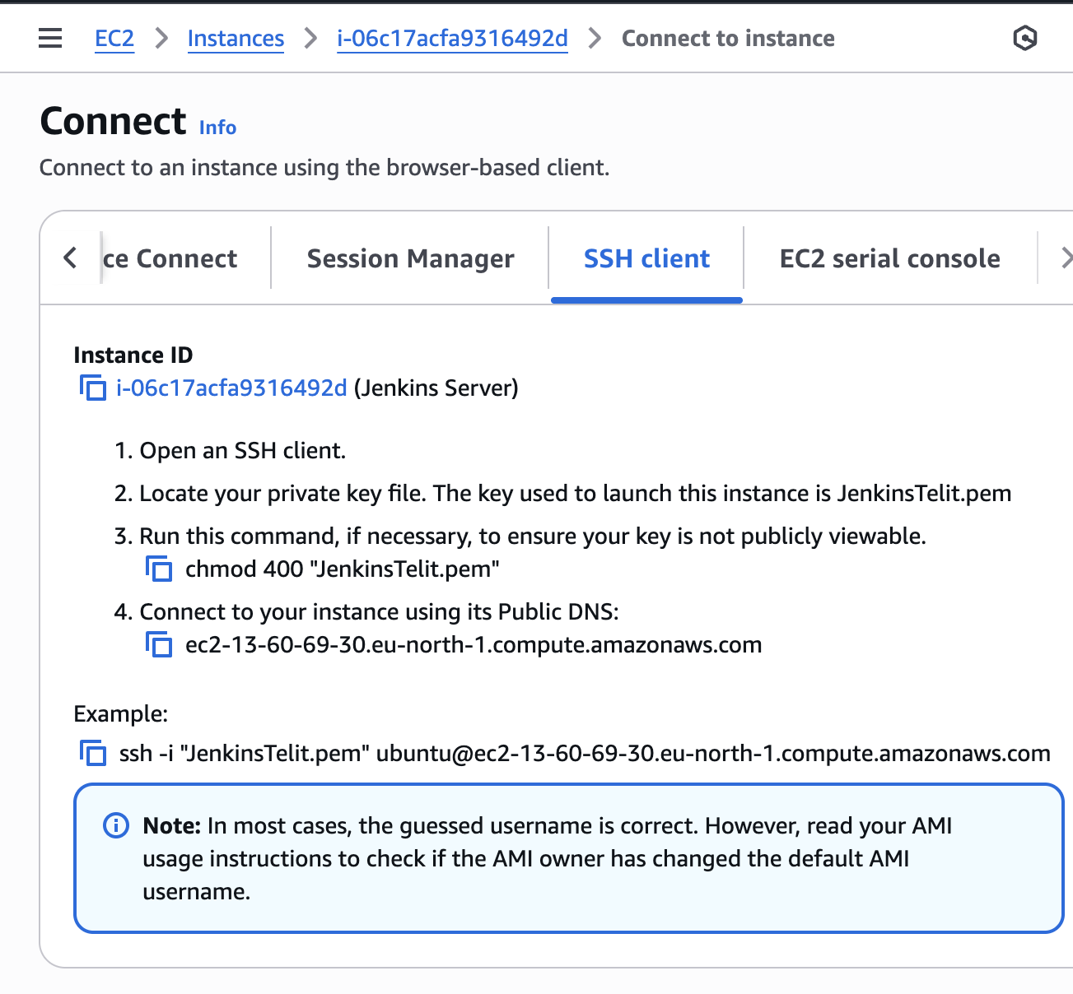

Open an SSH client.  
  
Locate your private key file. The key used to launch this instance is JenkinsTelit.pem  
  
Run this command, if necessary, to ensure your key is not publicly viewable.  
chmod 400 "JenkinsTelit.pem"  
  
Connect to your instance using its Public DNS:  
ec2-13-60-69-30.eu-north-1.compute.amazonaws.com  
  
ssh -i "JenkinsTelit.pem" ubuntu@ec2-13-60-69-30.eu-north-1.compute.amazonaws.com

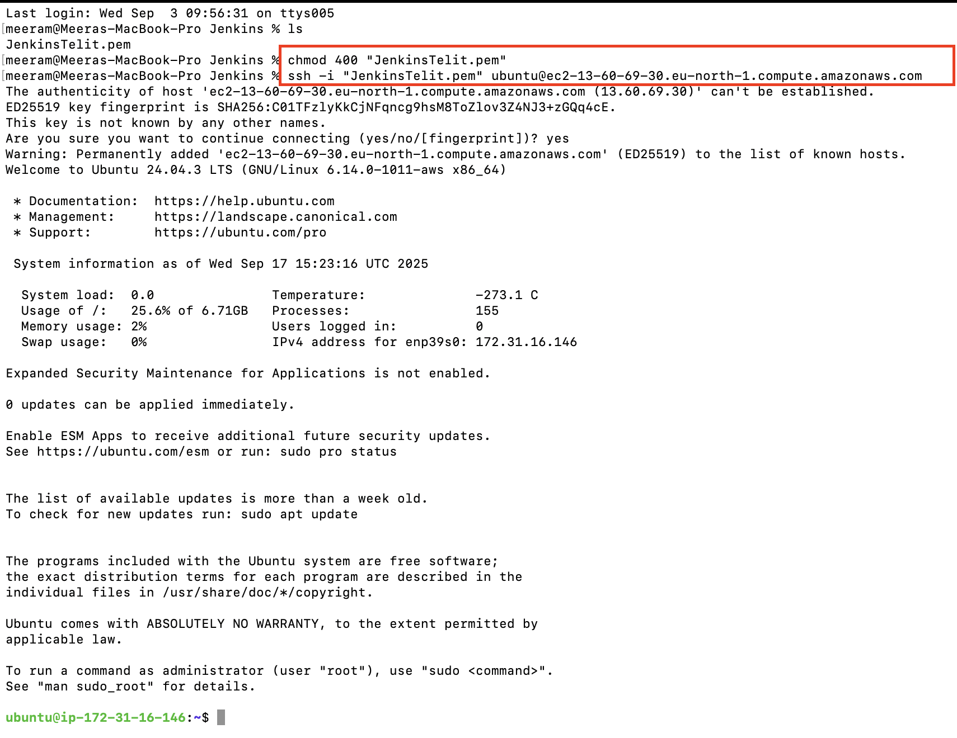

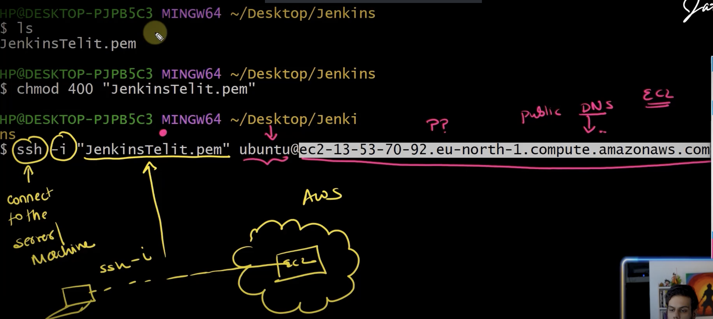

**Install Jenkins in AWS Server**

1. Jenkins is a java application, so first we need to install Java in the server  
   For a Non UI Based OS we install using apt (Advance packaging tool)
2. sudo su -🡪 to switch to the admin user  
   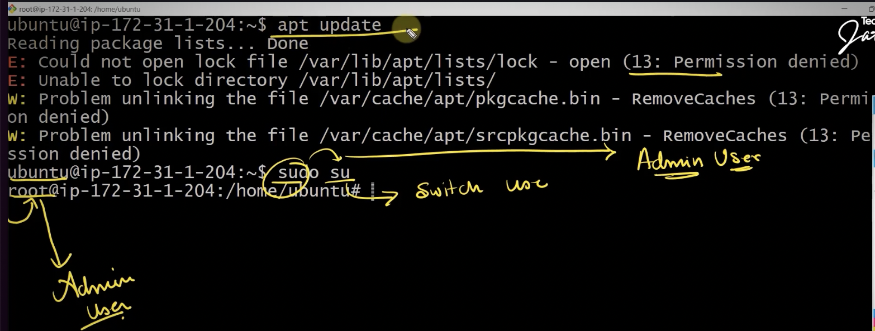
3. apt update
4. install java apt install openjdk-17-jre-headless
5. apt install maven  
   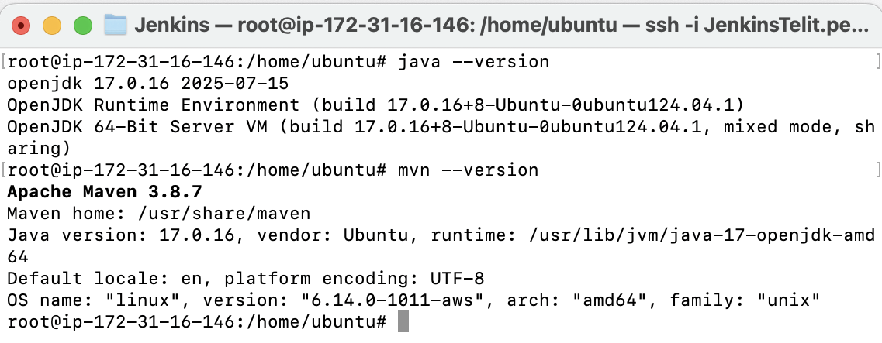
6. Go to Jenkins website and click download and select Ubuntu/Debian option – this is because we need to run Jenkins as a service, so if we the server is rebooted then we don’t have to manually go to the server and start Jenkins, instead it will automatically get started after the server reboot
7. Commands to install Jenkins  
   sudo wget -O /etc/apt/keyrings/jenkins-keyring.asc \

https://pkg.jenkins.io/debian-stable/jenkins.io-2023.key

echo "deb [signed-by=/etc/apt/keyrings/jenkins-keyring.asc]" \

https://pkg.jenkins.io/debian-stable binary/ | sudo tee \

/etc/apt/sources.list.d/jenkins.list > /dev/null

sudo apt-get update

sudo apt-get install Jenkins

1. To check whether the Jenkins is installed : systemctl status jenkins

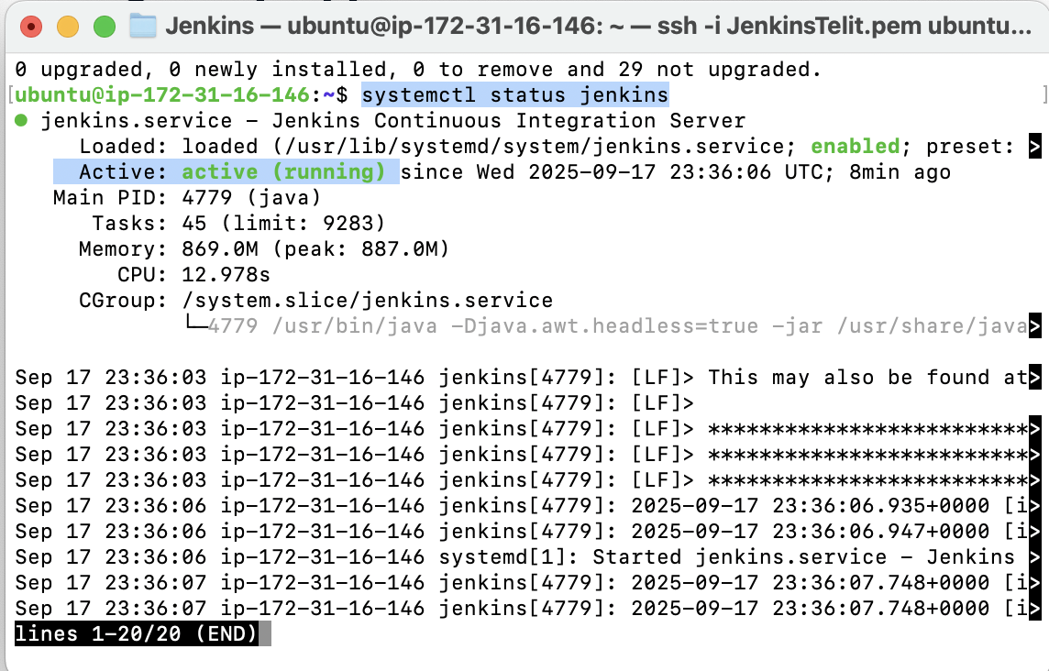

1. As per the security reason , the server (instance) only one port is open thru which we can ssh to the server, so inorder to access the Jenkins application in the i.e running in the server via browser, we need to make one more port (8080) for Jenkins application. For that go the instance in the AWS console and then click Security tab, click the group id and edit the inbound rules as shown below  
   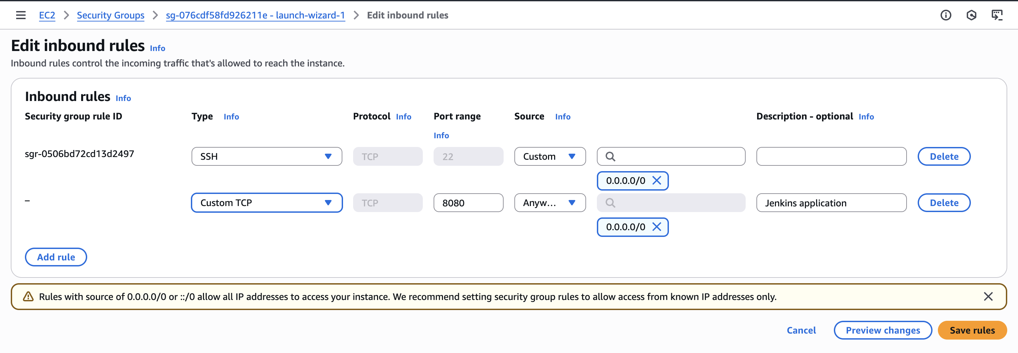

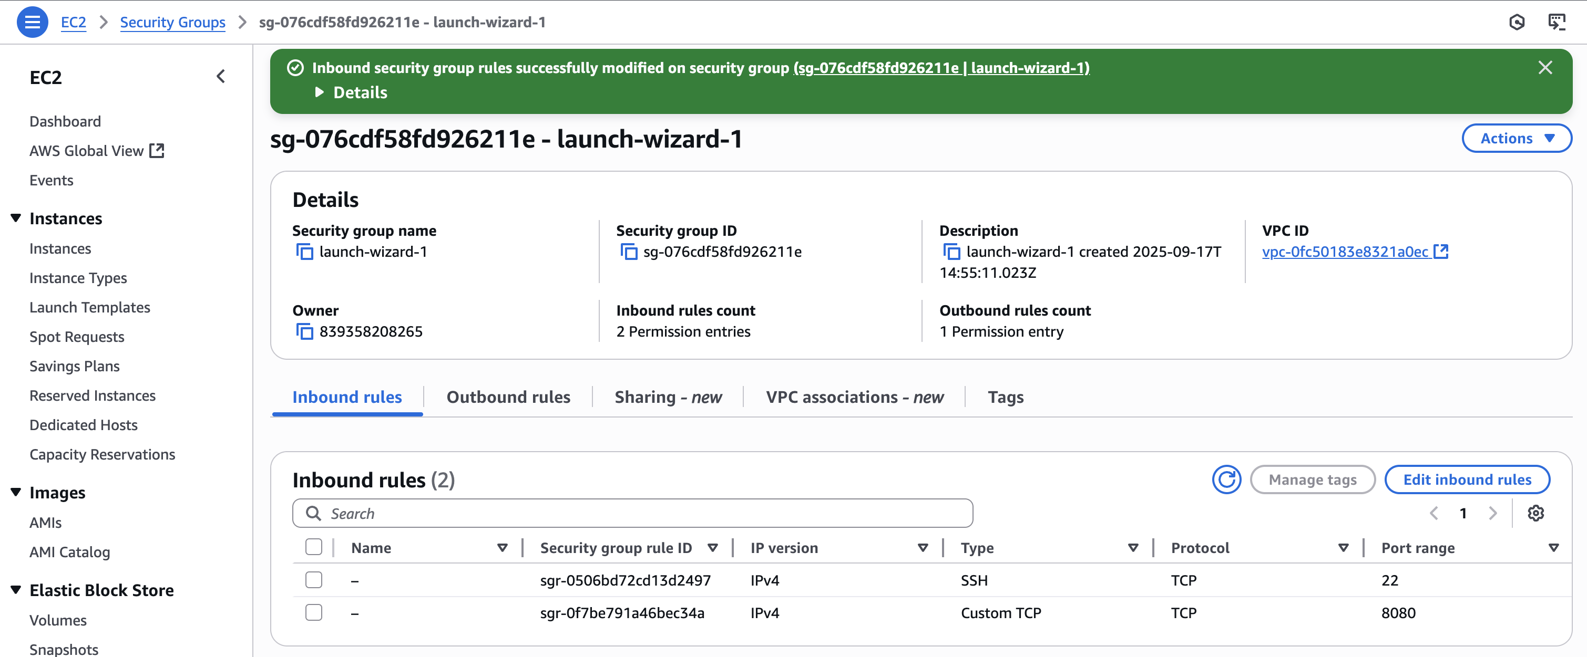

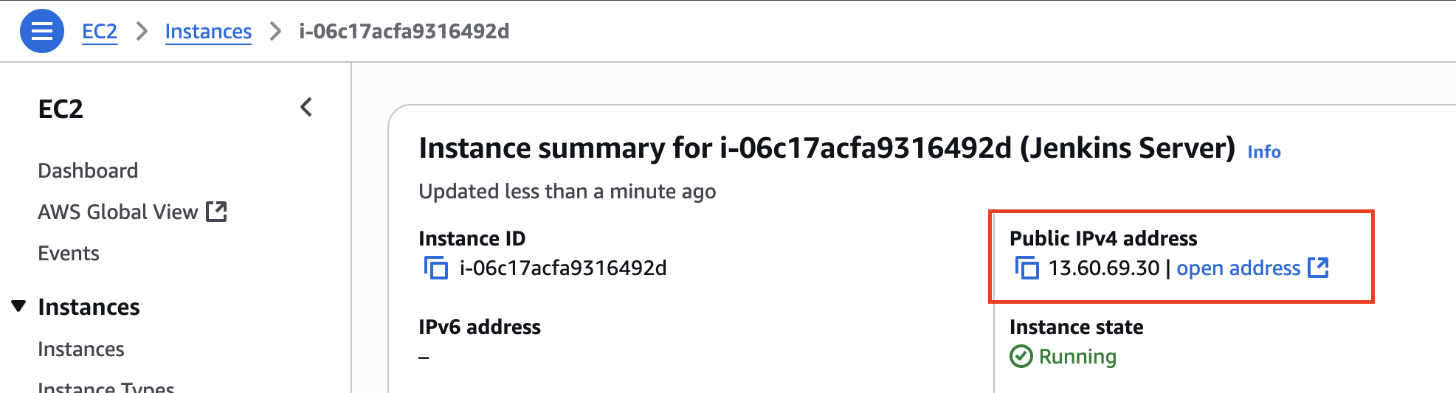

1. Go the ip address along with port : <http://13.60.69.30:8080>  
   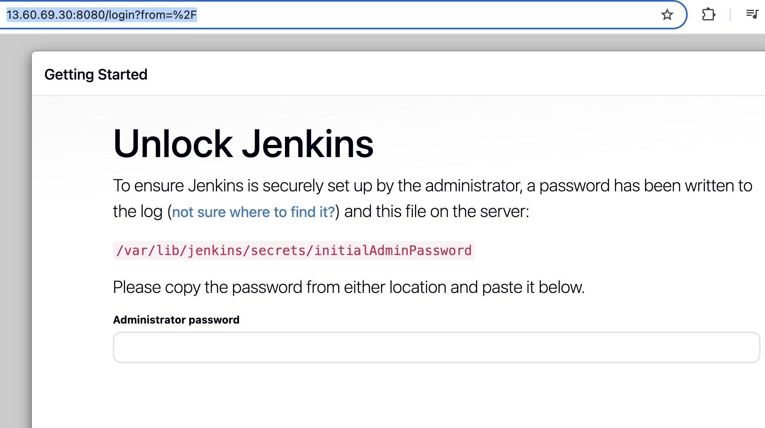
2. Go to the terminal, execute the following command to get the password  
   root@ip-172-31-16-146:/home/ubuntu# cat /var/lib/jenkins/secrets/initialAdminPassword

f4cceabacdce4a0f9169b7866e9a8a36

1. Install the suggested plugin
2. Create the first admin user (admin/admin)
3. Install the Maven Integration Plugin : go to Manage Jenkins > Install Maven Integration plugin
4. Configure the first Maven Project and add the mvn goal as  
   test -Dbrowser=chrome -DisLambdaTest=true -DisHeadless=false -X
5. **Passing parameters of Project thru Jenkins**test -Dbrowser=${BROWSER} -DisLambdaTest=${RUN_TEST_ON_LAMBDA} -DisHeadless=${HEADLESS} -X 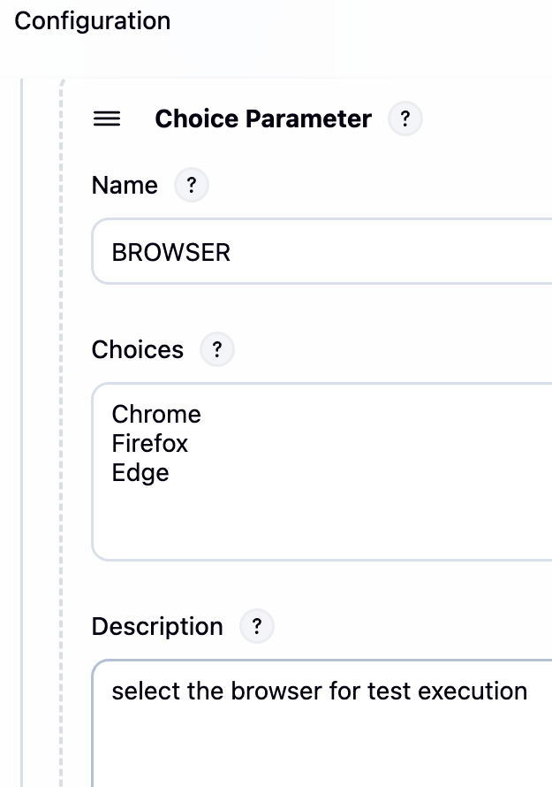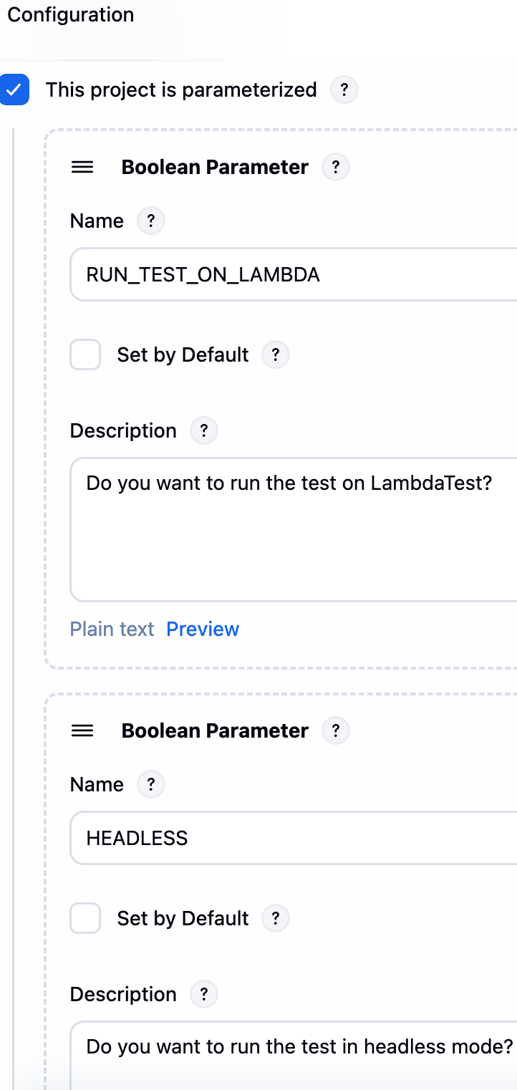

1. Test Analyser Plugin
2. TestNG Result Plugin
3. Set the cron job under build trigger, by selecting Build periodically  
   Add another plugin Parameterised scheduler, so that we could run the scheduler with parameters  
   TZ=Asia/Kolkata

39 16 * * *%RUN_TEST_ON_LAMBDA=true;HEADLESS=false;BROWSER=chrome

1. Emailing Reports from Jenkins